Bangladesh Medical Association (BMA)
List of Life Member-463
06. BMA Bogura Branch

Sl No | Voter No | Voter Details
1 | Voter No  LM-0600001  No Image | DR. MD. YEASIN  F/Name:  M/Name:  BM & DC Reg. No:  NID:  Cell:  Address:  Blood Group:  E X P I R E D
2 | Voter No  LM-0600002  No Image | DR. LT. COL. (RTD.) M.A SALAM  F/Name:  M/Name:  BM & DC Reg. No:  NID:  Cell:  Address: Santikunga Bhai Pagla, Magar Lane Bogura.  Blood Group:
3 | Voter No  LM-0600003  No Image | DR. MOHAMMAD ATAUL HAQUE  F/Name:  M/Name:  BM & DC Reg. No:  NID:  Cell:  Address: Enayet Ali Khan Lane Katnerpara Bogura.  Blood Group:
4 | Voter No  LM-0600004  No Image | DR. MST. AMATUL KAHAR  F/Name:  M/Name:  BM & DC Reg. No:  NID:  Cell:  Address: Enayet Ali Khan Lane Katenerpara Bogura.  Blood Group:
5 | Voter No  LM-0600005  No Image | DR. MD. ABDUR RASHID TALUKDER  F/Name:  M/Name:  BM & DC Reg. No:  NID:  Cell:  Address: Arif Chikitsha Kendra Jleswaritola Bogura.  Blood Group:
6 | Voter No  LM-0600006  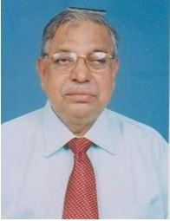 | DR. HEDAYETUL ISLAM  F/Name:  M/Name:  BM & DC Reg. No:  NID:  Cell: 01711972372  Address: Polash Clinic Katnar Para, Bogura.  Blood Group:
7 | Voter No  LM-0600007  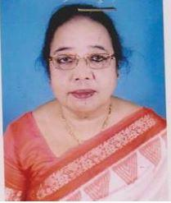 | DR. SHAMSUNNAHER ISLAM  F/Name:  M/Name:  BM & DC Reg. No:  NID:  Cell: 01711425925  Address: Polash Clinic Katnar Para, Bogura  Blood Group:
8 | Voter No  LM-0600008  No Image | DR. A.K.M. AKKAS ALI  F/Name:  M/Name:  BM & DC Reg. No:  NID:  Cell: 01731291700  Address: Janata Medical Nawabbari, Bogura  Blood Group:
9 | Voter No  LM-0600009 | DR. A.H.M. MUSHIHUR RAHMAN  F/Name:  M/Name:  BM & DC Reg. No:  NID:  Cell: 01711016870  Address: Bogura Nursing Home Bogura.  Blood Group:
10 | Voter No  LM-0600010  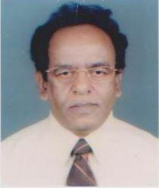 | DR. N. C. BARAI  F/Name:  M/Name:  BM & DC Reg. No:  NID:  Cell: 01715039740  Address: Netraloy Rahman Nagar, Bogura  Blood Group:
11 | Voter No  LM-0600011  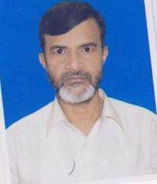 | DR. MONIRUL HOQUE  F/Name:  M/Name:  BM & DC Reg. No:  NID:  Cell: 01710663185  Address: Polytechnic Institute Bogra  Blood Group:
12 | Voter No  LM-0600012  No Image | DR. ARSHAD SAYEED  F/Name:  M/Name:  BM & DC Reg. No:  NID:  Cell: 01711460050  Address: Dr. Mofizuddin House Sutrapur, Bogra  Blood Group:
13 | Voter No  LM-0600013  No Image | DR. MD. MOSADDEQUR RAHMAN  F/Name:  M/Name:  BM & DC Reg. No:  NID:  Cell: 01715058405  Address: Annesha Ultrosonography Sutrapur, Bogra  Blood Group:
14 | Voter No  LM-0600014  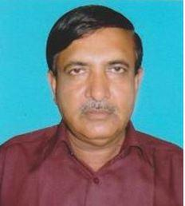 | DR. ABDUL KHALEQUE  F/Name:  M/Name:  BM & DC Reg. No:  NID:  Cell: 01711361426  Address: Chalklokman Bogra  Blood Group:
15 | Voter No  LM-0600015  No Image | DR. ABUL HOSSAIN  F/Name:  M/Name:  BM & DC Reg. No:  NID:  Cell: 01719251065  Address: Aziz Medical Store 2, Rail Gate, Bogra  Blood Group:
16 | Voter No  LM-0600016 | DR. SHAH MD. SHAHJAHAN ALI  F/Name:  M/Name:  BM & DC Reg. No:  NID:  Cell: 01711890555  Address: Sharmin Clinic Bou Bazar, S.P. Bridge, Bogra  Blood Group:
17 | Voter No  LM-0600017  No Image | DR. GULSHAN ARA  F/Name:  M/Name:  BM & DC Reg. No:  NID:  Cell: 01712512515  Address: Yusuf Kazi Lane, Rahman Nagar Bogra  Blood Group:
18 | Voter No  LM-0600018  No Image | DR. A.K.M. ASADUZZAMAN  F/Name:  M/Name:  BM & DC Reg. No:  NID:  Cell:  Address: Yusuf Kazi Lane Rahman Nagar Bogra  Blood Group:
19 | Voter No  LM-0600019 | DR. MD. MOSTAFA ALAM (NANNU)  F/Name:  M/Name:  BM & DC Reg. No:  NID:  Cell: 01711451825  Address: “NILANZANA” Chalklokman Bogra  Blood Group:
20 | Voter No  LM-0600020  No Image | DR. MD. BADI-UZ-ZAMAN  F/Name:  M/Name:  BM & DC Reg. No:  NID:  Cell: 01911564984  Address: Zaman Monzil Banomalideb Lane, Bogra  Blood Group:
21 | Voter No  LM-0600021  No Image | DR. N.A.M. GOLAM MAHBUB  F/Name:  M/Name:  BM & DC Reg. No:  NID:  Cell: 01711302037  Address: Mohammad Ali Hospital Bogra  Blood Group:
22 | Voter No  LM-0600022  No Image | DR. KHWAJA ABDUL GOFUR  F/Name:  M/Name:  BM & DC Reg. No:  NID:  Cell: 01711128938  Address: Medical Officer, TBS Hospital Nishandara, Bogra  Blood Group:
23 | Voter No  LM-0600023  No Image | DR. SHAMIM AHMED CHOWDHURY  F/Name:  M/Name:  BM & DC Reg. No:  NID:  Cell: 01711101514  Address: Rahman Nagar Bogra  Blood Group:
24 | Voter No  LM-0600024  No Image | DR. SHAMIM FERDOUS  F/Name:  M/Name:  BM & DC Reg. No:  NID:  Cell:  Address: Nibir Nursing Home TH & NT, Sherpur Bogra  Blood Group:
25 | Voter No  LM-0600025  No Image | DR. MD. ZAHURUL ISLAM  F/Name:  M/Name:  BM & DC Reg. No:  NID:  Cell: 0175007319  Address: Dy. Civil Surgeon Bogra  Blood Group:
26 | Voter No  LM-0600026  No Image | DR. MOUDUD HOSSAIN ALAMGIR PAVEL  F/Name:  M/Name: 01711869325  BM & DC Reg. No:  NID:  Cell:  Address: Bagbari House, Sutrapur, Bogra  Blood Group:
27 | Voter No  LM-0600027  No Image | DR. MD. ABDUL JALIL  F/Name:  M/Name:  BM & DC Reg. No:  NID:  Cell: 01558777893  Address: TH & FPO Thana Health Complex Gabtali, Bogra  Blood Group:
28 | Voter No  LM-0600028  No Image | DR. MD. SAYEDUL HOQUE  F/Name:  M/Name:  BM & DC Reg. No:  NID:  Cell:  Address: TH & FPO Thana Health Complex Sherpur, Bogra  Blood Group:
29 | Voter No  LM-0600029  No Image | DR. RUMANA SHAIKH  F/Name:  M/Name:  BM & DC Reg. No:  NID:  Cell:  Address: Consultant, Gynae M.A. Hospital Bogra  Blood Group:
30 | Voter No  LM-0600030  No Image | DR. A.K.M. KAMRUL AHSAN RANJU  F/Name:  M/Name:  BM & DC Reg. No:  NID:  Cell: 01712018856  Address: Medical Officer Thana Health Complex Sherpur, Bogra  Blood Group:
31 | Voter No  LM-0600031  No Image | DR. GULNAHAR BANU (BINA)  F/Name:  M/Name:  BM & DC Reg. No:  NID:  Cell: 01749670464  Address: Medical Officer M.A Hospital, Bogra  Blood Group:
32 | Voter No  LM-0600032  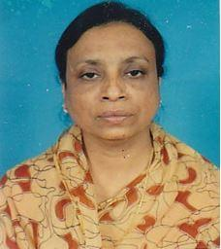 | DR. LUTFUNNESSA  F/Name:  M/Name:  BM & DC Reg. No:  NID:  Cell: 01711193936  Address: Medical Officer Thana Health Complex Sherpur, Bogra  Blood Group:
33 | Voter No  LM-0600033  No Image | DR. MD. ABDUL MAZID  F/Name:  M/Name:  BM & DC Reg. No:  NID:  Cell:  Address: Kamosgari Baganbari, Bogra  Blood Group:
34 | Voter No  LM-0600034  No Image | DR. RATU RUMANA BINTE RAHMAN  F/Name:  M/Name:  BM & DC Reg. No:  NID:  Cell:  Address: Jr. Consultant (CC) Thana Health Complex Sherpur, Bogra  Blood Group:
35 | Voter No  LM-0600035  No Image | DR. MD. REZAUL KARIM  F/Name:  M/Name:  BM & DC Reg. No:  NID:  Cell: 01711954844  Address: Medical Officer Thana Health Complex Sherpur, Bogra  Blood Group:
36 | Voter No  LM-0600036 | DR. MD. SHAHEEN ALAM  F/Name:  M/Name:  BM & DC Reg. No:  NID:  Cell: 01711786408  Address: Thana Health Complex Dhunot, Bogra  Blood Group:
37 | Voter No  LM-0600037  No Image | DR. DEWAN MD. EMDADUL HOQUE  F/Name:  M/Name:  BM & DC Reg. No:  NID:  Cell:  Address: IDI Services Beximco Pharma Jalleshari Bogra  Blood Group:
38 | Voter No  LM-0600038  No Image | DR. ATANU KUMAR BASAK  F/Name:  M/Name:  BM & DC Reg. No:  NID:  Cell: 01711119475  Address: Medical Officer Thana Health Complex Sherpur, Bogra  Blood Group:
39 | Voter No  LM-0600039 | DR. MD. AZFARUL HABIB ROSE  F/Name:  M/Name:  BM & DC Reg. No:  NID:  Cell: 01711425983  Address: Jaleswaritola Bogra  Blood Group:
40 | Voter No  LM-0600040  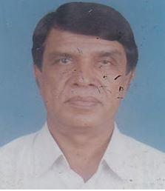 | DR. MD. ABDUL HOQUE  F/Name:  M/Name:  BM & DC Reg. No:  NID:  Cell: 01712185008  Address: “Renu Villa” Thanthania, Bogra.  Blood Group:
41 | Voter No  LM-0600041  No Image | DR. MD. NURAL ISLAM  F/Name:  M/Name:  BM & DC Reg. No:  NID:  Cell: 01714422720  Address: Medical Officer Thana Health Complex Shibganj, Bogra  Blood Group:
42 | Voter No  LM-0600042 | DR. MD. REZAUL ALAM JEWEL  F/Name: Md. Abdul Aziz Sarkar  M/Name:  BM & DC Reg. No:  NID:  Cell: 01711372723  Address: A2/ Amicus Shopnaneer Rahman N Agar, Bogra  Blood Group:
43 | Voter No  LM-0600043  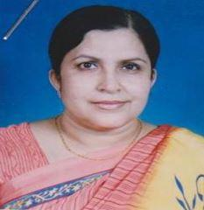 | DR. SHAMS SAELA BANU  F/Name:  M/Name:  BM & DC Reg. No:  NID:  Cell:  Address: Jaleswaritola Bogra  Blood Group:
44 | Voter No  LM-0600044  No Image | DR. ZAKIA NAZNEEN  F/Name:  M/Name:  BM & DC Reg. No:  NID:  Cell:  Address: Lecturer, Physio SZRMC, Bogra  Blood Group:
45 | Voter No  LM-0600045  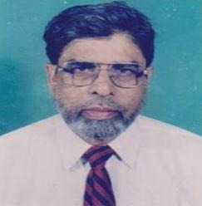 | DR. SHAH MD. NURAN NABI  F/Name:  M/Name:  BM & DC Reg. No:  NID:  Cell:  Address: Care Medicine Centre Nowabbari Road, Bogra  Blood Group:
46 | Voter No  LM-0600046  No Image | DR. MD. SAIDUR RAHMAN ROBIN  F/Name:  M/Name:  BM & DC Reg. No:  NID:  Cell: 01711451748  Address: Assistant Prof. (Physiology) SZMC, Bogra  Blood Group:
47 | Voter No  LM-0600047  No Image | DR. MD. FERDOUS ALAM  F/Name:  M/Name:  BM & DC Reg. No:  NID:  Cell:  Address: Medical Officer Seprosy, C.S.O., Bogra  Blood Group:
48 | Voter No  LM-0600048  No Image | DR. MANJIRA RAHMAN DITA  F/Name:  M/Name:  BM & DC Reg. No:  NID:  Cell: 01714258353  Address: Lecturer, Biochemistry Dept. SZRMC Bogra  Blood Group:
49 | Voter No  LM-0600049  No Image | DR. A.N.M. ABDUR RAZZAQUE  F/Name:  M/Name:  BM & DC Reg. No:  NID:  Cell:  Address: Thana Health Complex Adamdighi, Bogra  Blood Group:  E X P I R E D
50 | Voter No  LM-0600050  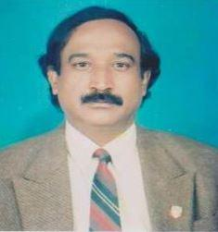 | DR. BIPLAB KUMAR BURMON  F/Name:  M/Name:  BM & DC Reg. No:  NID:  Cell: 01715385837  Address: Sherpur, Bogra  Blood Group:
51 | Voter No  LM-0600051  No Image | DR. MD. EMDADUL HOQUE  F/Name:  M/Name:  BM & DC Reg. No:  NID:  Cell: 01711010080  Address: Lecturer, Physio SZRMC, Bogra  Blood Group:
52 | Voter No  LM-0600052  No Image | DR. MD. EMDAD HOSSAIN  F/Name:  M/Name:  BM & DC Reg. No:  NID:  Cell: 01711869829  Address: Shamsun Nahar Clinic Thanthania, Bogra  Blood Group:
53 | Voter No  LM-0600053  No Image | DR. MD. MAHMUD HOSSAIN  F/Name:  M/Name:  BM & DC Reg. No:  NID:  Cell:  Address:  Blood Group:  TRANSFERED to BMA Dhaka City  LM-1405543
54 | Voter No  LM-0600054  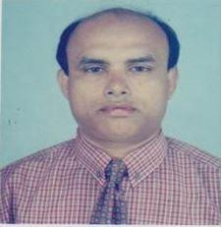 | DR. MD. ZAHURUL ISLAM  F/Name:  M/Name:  BM & DC Reg. No:  NID:  Cell:  Address: Medical Officer (MCHFP) Kahaloo, Bogra  Blood Group:
55 | Voter No  LM-0600055  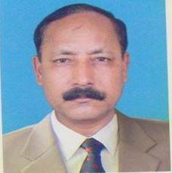 | DR. MOHAMMAD AZIZUL HAQUE  F/Name: Late Alhaj Mohammad Hossain  M/Name:  BM & DC Reg. No:  NID:  Cell:  Address: 406, Shaker House Nataipara (Chelopara), Bogra  Blood Group:
56 | Voter No  LM-0600056  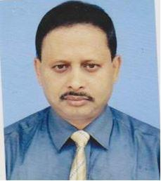 | DR. MD. ELIAS HOSSAIN  F/Name:  M/Name:  BM & DC Reg. No:  NID:  Cell:  Address: TH & FPO Thana Health Complex Kahaloo, Bogra  Blood Group:
57 | Voter No  LM-0600057  No Image | DR. NIRMALENDU CHOWDHURY  F/Name:  M/Name:  BM & DC Reg. No:  NID:  Cell: 01713790533  Address: Medical Officer Thana Health Complex Kahaloo, Bogra  Blood Group:  E X P I R E D
58 | Voter No  LM-0600058  No Image | DR. MD. TAHMIDUR RAHMAN  F/Name:  M/Name:  BM & DC Reg. No:  NID:  Cell:  Address: Medical Officer, FW Zamgram, FWC Kahaloo, Bogra  Blood Group:
59 | Voter No  LM-0600059  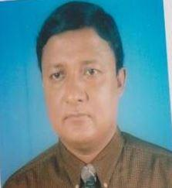 | DR. MD. ABDUL HAKIM  F/Name: Late Ishaque Ali  M/Name: Late Golenahar  BM & DC Reg. No: 17390  NID: 2843174653  Cell: 01712218266  Address: Chalklokman,bogura sadar,Bogura  Blood Group: B+
60 | Voter No  LM-0600060  No Image | DR. MD. WODUDUL HOQUE TARAFDER (NAHID)  F/Name:  M/Name:  BM & DC Reg. No:  NID:  Cell: 01716192179  Address: C/O.-Md. Wazed Hossain Tarafder Sutrapur, Bogra.  Blood Group:
61 | Voter No  LM-0600061  No Image | DR. MD. SHAHJAHAN KADER SIDDIKY  F/Name:  M/Name:  BM & DC Reg. No:  NID:  Cell:  Address: Lecturer Dept. Of Pathology SZRMC Bogra  Blood Group:
62 | Voter No  LM-0600062  No Image | DR. AHMED RAQUIB  F/Name:  M/Name:  BM & DC Reg. No:  NID:  Cell:  Address:  Blood Group:  TRANSFERED to BMA Dhaka City  LM-1405543
63 | Voter No  LM-0600063  No Image | DR. POJUSH KUMAR KUNDU  F/Name:  M/Name:  BM & DC Reg. No:  NID:  Cell:  Address: Lecturer, Anatomy Dept. SZRMC, Bogra  Blood Group:
64 | Voter No  LM-0600064  No Image | DR. MD. MIZANUR RAHMAN  F/Name:  M/Name:  BM & DC Reg. No:  NID:  Cell:  Address: Medical Officer Mohammad Ali Hospital Bogra  Blood Group:
65 | Voter No  LM-0600065  No Image | DR. MD. MOSTAFA KAMAL  F/Name:  M/Name:  BM & DC Reg. No:  NID:  Cell: 01713377021  Address: RMO. Bogra Diabetic Hospital Court House Street, Bogra  Blood Group:
66 | Voter No  LM-0600066  No Image | DR. MD. MOKBULAR RAHMAN  F/Name:  M/Name:  BM & DC Reg. No:  NID:  Cell: 01711887613  Address: Sutrapur Bogra  Blood Group:
67 | Voter No  LM-0600067  No Image | DR. MD. ABDUS SAMAD  F/Name:  M/Name:  BM & DC Reg. No:  NID:  Cell:  Address: Thana Health Complex Shibgonj, Bogra  Blood Group:
68 | Voter No  LM-0600068  No Image | DR. MD. HABIBUR RAHMAN  F/Name:  M/Name:  BM & DC Reg. No:  NID:  Cell: 01712154925  Address: Medical Officer Thana Health Complex Shibganj, Bogra.  Blood Group:
69 | Voter No  LM-0600069  No Image | DR. MD. MOSHAROF HOSSAIN  F/Name:  M/Name:  BM & DC Reg. No:  NID:  Cell:  Address: Medical Officer Thana Health Complex Shibganj, Bogra  Blood Group:
70 | Voter No  LM-0600070  No Image | DR. MD. ZAHURUL ISLAM  F/Name:  M/Name:  BM & DC Reg. No:  NID:  Cell: 01712503760  Address: Vill-Namuja P.O.-Buriganj, Bogra  Blood Group:
71 | Voter No  LM-0600071  No Image | DR. MD. SHAHJAHAN ALI  F/Name:  M/Name:  BM & DC Reg. No:  NID:  Cell: 01711368633  Address: Associate Professor Of Surgery SZMC, Bogra  Blood Group:
72 | Voter No  LM-0600072  No Image | DR. A.K.M. AHSAN HABIB  F/Name:  M/Name:  BM & DC Reg. No:  NID:  Cell: 01711425961  Address: Asstt. Prof., Radio Theraphy Bogra Medical College, Bogra  Blood Group:
73 | Voter No  LM-0600073  No Image | DR. MD. ANISUL HAQUE  F/Name:  M/Name:  BM & DC Reg. No:  NID:  Cell:  Address: S. Chattarjee Lane Jaleswaritola, Bogra  Blood Group:
74 | Voter No  LM-0600074  No Image | DR. PANKAJ POUL  F/Name:  M/Name:  BM & DC Reg. No:  NID:  Cell:  Address: Medical Officer Bangladesh Bank, Bogra  Blood Group:
75 | Voter No  LM-0600075  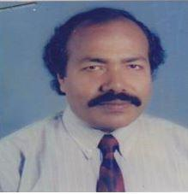 | DR. SHEIKH MD. RAZAUL AMEEN FERDOUSHEE (NAYON)  F/Name:  M/Name:  BM & DC Reg. No:  NID:  Cell: 01711407305  Address: Pyeri Shankar Road Katnar Para, Bogra  Blood Group:
76 | Voter No  LM-0600076  No Image | DR. SELINA SULTANA  F/Name:  M/Name:  BM & DC Reg. No:  NID:  Cell:  Address: Arif Chikissha Kendra Jaleswaritola Bogra  Blood Group:
77 | Voter No  LM-0600077  No Image | DR. SHORIFUR RASHID DIPU  F/Name:  M/Name:  BM & DC Reg. No:  NID:  Cell: 01715011656  Address: Arif Chikissha Kendra Jaleswaritola, Bogra  Blood Group:
78 | Voter No  LM-0600078  No Image | DR. NAKUL KUMAR DATTA  F/Name:  M/Name:  BM & DC Reg. No:  NID:  Cell:  Address: Bogura  Blood Group:  TRANSFERED to BMA Dhaka City  LM-1405543
79 | Voter No  LM-0600079  No Image | DR. MD. YOUSUF MIAH  F/Name:  M/Name:  BM & DC Reg. No:  NID:  Cell: 01716181837  Address: Eye Specialist Sherpur Road, Bogra  Blood Group:
80 | Voter No  LM-0600080  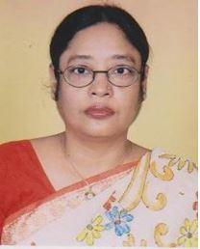 | DR. UMMEE QULSUM  F/Name: Late Dr. Asir Uddin Sardar  M/Name:  BM & DC Reg. No:  NID:  Cell: 01711981833  Address: Medical Officer Kahaloo Health Complex, Bogra  Blood Group:
81 | Voter No  LM-0600081  No Image | DR. SYED MAINUL HASAN SADIK  F/Name: Syed Mokbulur Rahman  M/Name: 01711875028  BM & DC Reg. No: 10852  NID:  Cell:  Address: Associate Professor Of Medicine Sahid Ziaur Rahman Medical College Bogra  Blood Group:
82 | Voter No  LM-0600082  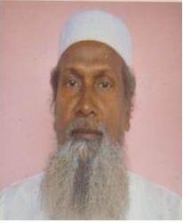 | DR. SAIDUZZAMAN  F/Name:  M/Name:  BM & DC Reg. No:  NID:  Cell:  Address: Shafi Clinic Naruli (Chalopara), Shariakandi Road Bogra  Blood Group:
83 | Voter No  LM-0600083  No Image | DR. ZAHEDUL KAMAL  F/Name:  M/Name:  BM & DC Reg. No:  NID:  Cell:  Address: Nibir Nursing Home Thonthonia Bogra  Blood Group:
84 | Voter No  LM-0600084  No Image | DR. MD. SHAHIDUR RAHMAN  F/Name:  M/Name:  BM & DC Reg. No:  NID:  Cell: 01712748899  Address: Thana Health Complex Gabtoli, Bogra  Blood Group:
85 | Voter No  LM-0600085  No Image | DR. MD. SAMIR HOSSAIN MISHU  F/Name:  M/Name:  BM & DC Reg. No:  NID:  Cell: 01710792222  Address: Jaleshwaritola Bogra  Blood Group:
86 | Voter No  LM-0600086  No Image | DR. MOHAMMAD TOFAZZOL HOSSAIN  F/Name:  M/Name:  BM & DC Reg. No:  NID:  Cell: 01713706761  Address: Vill-Ramchandropur Madda, Bogra  Blood Group:
87 | Voter No  LM-0600087  No Image | DR. MD. SHAHIN AKHTER  F/Name:  M/Name:  BM & DC Reg. No:  NID:  Cell: 01711014190  Address: Maloti Nagor Mondolpara, Bogra  Blood Group:
88 | Voter No  LM-0600088  No Image | DR. MD. MOZAMMEL HOQUE  F/Name:  M/Name:  BM & DC Reg. No:  NID:  Cell: 01712185004  Address: Medical Officer Dupehachia Health Compelx Bogra  Blood Group:
89 | Voter No  LM-0600089  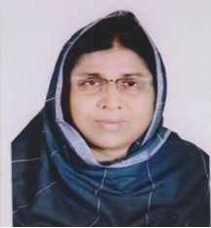 | DR. AKHTARI HOSSAIN CHOWDHURY NIPA  F/Name: Dr. A.n. Asmal Hossain Chowdhury  M/Name:  BM & DC Reg. No:  NID:  Cell: 01711981827  Address: Rahman Nagar, Bogra  Blood Group:
90 | Voter No  LM-0600090  No Image | DR. MOHAMMAD ALAMGIR CHOWDHURY  F/Name:  M/Name:  BM & DC Reg. No:  NID:  Cell:  Address:  Blood Group:  TRANSFERED to BMA Dhaka City  LM-1405543
91 | Voter No  LM-0600091  No Image | DR. MUZIBUR RAHMAN  F/Name:  M/Name:  BM & DC Reg. No:  NID:  Cell:  Address:  Blood Group:  TRANSFERED to BMA Dhaka City  LM-1405543
92 | Voter No  LM-0600092  No Image | DR. SALIM MD. ANSARI  F/Name:  M/Name:  BM & DC Reg. No:  NID:  Cell: 01711974845  Address: Director Necluar Medical Centre Bogra.  Blood Group:
93 | Voter No  LM-0600093  No Image | DR. BELAL UDDIN  F/Name:  M/Name:  BM & DC Reg. No:  NID:  Cell: 01713700649  Address: Medical Officer Rural Development Academy Sherpur, Bogra  Blood Group:
94 | Voter No  LM-0600094  No Image | DR. MD. SHOFIQUL ALAM  F/Name:  M/Name:  BM & DC Reg. No:  NID:  Cell: 01711401444  Address: Rahmatia Lodge PTI Lane Navana Goli, Bogra  Blood Group:
95 | Voter No  LM-0600095  No Image | DR. ZAHIRUL KAMAL  F/Name:  M/Name:  BM & DC Reg. No:  NID:  Cell:  Address: Drream Khanachyari Sherpur, Bogra  Blood Group:
96 | Voter No  LM-0600096  No Image | DR. TAHMINA AFROZA (HERA)  F/Name:  M/Name:  BM & DC Reg. No:  NID:  Cell:  Address: Maleka Diognostic Centre Sutrapur, Bogra.  Blood Group:
97 | Voter No  LM-0600097  No Image | DR. MD. SERAJUL ISLAM  F/Name: Late Eradeth Hossain  M/Name:  BM & DC Reg. No:  NID:  Cell:  Address: Maleka Diagnostic Centre Sutrapur, Bogra.  Blood Group:
98 | Voter No  LM-0600098  No Image | DR. MD. SHAHINUR RAHMAN  F/Name: Mr. Hamidur Rahman  M/Name:  BM & DC Reg. No:  NID:  Cell: 01711467176  Address: Asstt. Prof. (Dormatoly) SZRMC, Bogra.  Blood Group:
99 | Voter No  LM-0600099  No Image | DR. SHAMIM FATEMA NARGIS  F/Name:  M/Name:  BM & DC Reg. No:  NID:  Cell: 01713200271  Address: Asstt. Prof. (Gynaecology) SZRMC., Bogra.  Blood Group:
100 | Voter No  LM-0600100  No Image | DR. A.J.U. NASIMA  F/Name:  M/Name:  BM & DC Reg. No:  NID:  Cell:  Address: Consultant (Gynaecology) Mohammad Ali Hospital, Bogra.  Blood Group:
101 | Voter No  LM-0600101  No Image | DR. SAMIRAN KUMAR SAHA  F/Name:  M/Name:  BM & DC Reg. No:  NID:  Cell:  Address: Associate Prof., Medicine Bogra Medical College Bogra  Blood Group:
102 | Voter No  LM-0600102  No Image | DR. MD. NAZRUL ISLAM  F/Name: Late Rais Uddin Ahmed  M/Name:  BM & DC Reg. No: 4574  NID:  Cell:  Address: Vice Principal, Health Ways Institute Of Medical Technology Carmical Road, Bogra  Blood Group:
103 | Voter No  LM-0600103  No Image | DR. MD. ABDUL GAFFAR FARUK  F/Name: Mr. Shafi Ahmed  M/Name:  BM & DC Reg. No:  NID:  Cell: 01711301892  Address: Associate Prof. Health Of Department, ENT SZMC, Bogra  Blood Group:
104 | Voter No  LM-0600104  No Image | DR. MD. ABDUL BASED  F/Name: Late Amin Ali Pramanik  M/Name:  BM & DC Reg. No:  NID:  Cell: 01711364993  Address: Associate Prof. C.C (Ortho Surgery) SZRMC, Bogra  Blood Group:
105 | Voter No  LM-0600105  No Image | DR. A. K. M. MASUDUR RAHMAN  F/Name: Md. Nazmul Haque  M/Name:  BM & DC Reg. No:  NID:  Cell: 01716061597  Address: Consultant Medicine Mohammad Ali Hospital, Bogra  Blood Group:
106 | Voter No  LM-0600106  No Image | DR. GHAZI SHAIFUL ALAM CHOUDHURY  F/Name: Ghazi Siddique Hossain Choudhury  M/Name:  BM & DC Reg. No:  NID:  Cell: 01711393227  Address: 18, Central Eid Gha Road Sutrapur, Bogra  Blood Group:  E X P I R E D
107 | Voter No  LM-0600107  No Image | DR. ROWSHAN JAHAN  F/Name: Alhaj Abdul Wasid Khan  M/Name:  BM & DC Reg. No:  NID:  Cell: 01712043461  Address: Al Madina Clinic, Kanoch Gari Sherpur Road, Bogra  Blood Group:
108 | Voter No  LM-0600108  No Image | DR. M.A. MATIN  F/Name: Md. Ali Hasan  M/Name:  BM & DC Reg. No:  NID:  Cell: 01725897870  Address: Balaka Garden' Chaksutra Pur, Bogra  Blood Group:
109 | Voter No  LM-0600109 | DR. MD. MUNSUR RAHMAN  F/Name: Md. Moslem Uddin  M/Name:  BM & DC Reg. No:  NID:  Cell: 01711869682  Address: Md. Moslem Uddin Seba Poly Clinic Katnarpara, Bogra  Blood Group:
110 | Voter No  LM-0600110  No Image | DR. FARRUQE AHMED  F/Name: Md. Muslim Uddin  M/Name:  BM & DC Reg. No:  NID:  Cell: 01711267044  Address: GSA. Model Clinic Thanthania, Sherpur, Bogra  Blood Group:
111 | Voter No  LM-0600111  No Image | DR. SHAIKH MD. SHAHIDUL HAQUE  F/Name: S.M. Nasir Uddin  M/Name:  BM & DC Reg. No:  NID:  Cell: 01711317115  Address: Asstt. Prof. SZRMC. Bogra  Blood Group:
112 | Voter No  LM-0600112 | DR. ALHAJ A.K.M.MAHFUZUR RAHMAN RANA  F/Name: Late Afsar Uddin Ahmed  M/Name:  BM & DC Reg. No:  NID:  Cell: 01712051879  Address: Dinar Diagnostic Sathmatha, Bogra.  Blood Group:
113 | Voter No  LM-0600113  No Image | DR. FAROUQUE SULTAN  F/Name: Sekendar Ali  M/Name:  BM & DC Reg. No:  NID:  Cell: 01726725227  Address: Medical Officer Prison Hopital, Bogra  Blood Group:
114 | Voter No  LM-0600114  No Image | DR. MST. HASINA AKHTHER  F/Name: Md. Akkas Ali  M/Name: Hosne Ara Begum  BM & DC Reg. No: 28006  NID: 1022002013882  Cell: 01712192494  Address: Flat No. 7/A, Monjur Tower, Sherpur Road, Jaleshwaritala, Bogura-5800.  Blood Group: AB+
115 | Voter No  LM-0600115  No Image | DR. MD. ROWSHAN ALI  F/Name: Md. Jafar Ali  M/Name:  BM & DC Reg. No:  NID:  Cell:  Address: 5/24, Tetultala Thanthania, Bogra  Blood Group:
116 | Voter No  LM-0600116  No Image | DR. MD. AZIZUR RAHMAN  F/Name: Late Nasim Uddin Ahmed  M/Name:  BM & DC Reg. No:  NID:  Cell: 01710789482  Address: Chest Diseases Clinic Bogra  Blood Group:
117 | Voter No  LM-0600117  No Image | DR. EZAJ AHMED  F/Name: A. B. Manjur Ahmed  M/Name: Bilkis Suraiya  BM & DC Reg. No: 21450  NID: 5992063981  Cell: 01712072771  Address: Flat No. 7/A, Monjur Tower, Sherpur Road, Jaleshwaritala, Bogura-5800.  Blood Group: A+
118 | Voter No  LM-0600118  No Image | DR. NRIPENDRA NARAYAN RAY  F/Name: Late Aurjun Chandra Ray  M/Name:  BM & DC Reg. No:  NID:  Cell:  Address: Upazila Health Complex Nandigram Bogra  Blood Group:
119 | Voter No  LM-0600119  No Image | DR. A.K.M. ANISUR RAHMAN  F/Name: Abu Ahmed Abdullah  M/Name:  BM & DC Reg. No:  NID:  Cell: 01711875889  Address: Associate Porf. Of Ortho. Surgery SZMC, Bogra  Blood Group:
120 | Voter No  LM-0600120  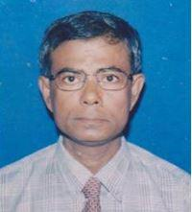 | DR. ABU TAHER MD. AMINUL ISLAM  F/Name: Late Dr. Md. Rais Uddin  M/Name: Mrs. Begum Amena Kahtun  BM & DC Reg. No: 12556  NID:  Cell:  Address: Dr. Abu Taher Md. Aminul Islam, Seuzgari, Charmichael Road Po+Ps+Dist: Bogra  Blood Group: B+
121 | Voter No  LM-0600121  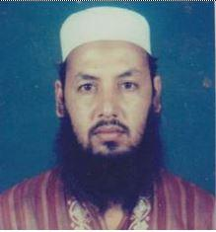 | DR. MD AMINUL ISLAM  F/Name: Md Shasur Rahman Mondol  M/Name: Late Mrs. Kodovan Bibi  BM & DC Reg. No:  NID: 1022008070059  Cell: 01715081139  Address: Gulshan Housing, Seujgari Camical Rd, Bogra  Blood Group: B+
122 | Voter No  LM-0600122  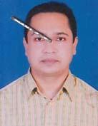 | DR. S.H.M. SHAH ALI  F/Name: Late. Ishaque Ali  M/Name: Late. Ayesha Khatun  BM & DC Reg. No: 20869  NID: 1028805627697  Cell: 01711425970  Address: Sheba Nursing Home, Sherpur, Bogra  Blood Group: B+
123 | Voter No  LM-0600123  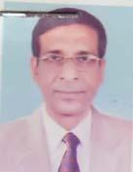 | DR. MAHMUD HOSSAIN  F/Name: Late. Anwar Hossain  M/Name: Mahmuda Begum  BM & DC Reg. No: 13121  NID: 1022007060080  Cell: 01718501625  Address: Vill: Baniagati, P.O: Vangabari, Thana: Belkuchi, Dist.- Serajgong  Blood Group: B+
124 | Voter No  LM-0600124  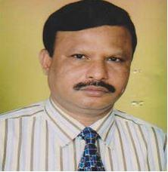 | DR. MD. RASHIDUL ISLAM  F/Name: Late. Mojir Uddin Ah  M/Name: Late. Rahima Khatun  BM & DC Reg. No: 11977  NID: 1022007064263  Cell: 01711436568  Address: Assistant Professor (Dermatology), LPR Shaheed Ziaur Rahman Medical College, Bogra  Blood Group: O+
125 | Voter No  LM-0600125 | DR. MD. MAHBUBUR RAHMAN  F/Name: Late. Sk. Abdur Rahman  M/Name: Late. Tamirun Nesa  BM & DC Reg. No: 16945  NID: 1022012108763  Cell: 01902-125653  Address: C/O: Md. Abdul Latif, Vill: Khander Gohail Road, Bogra  Blood Group: O+
126 | Voter No  LM-0600126  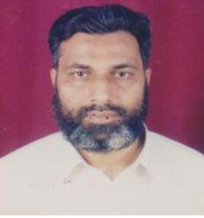 | DR. A.K.M ROWNAK HOSSAIN CHOWDHURY  F/Name: Dr. Azmal Hossain Chowdhury  M/Name: Mst. Rahima Khatun  BM & DC Reg. No: 13346  NID:  Cell: 01712770043  Address: Asstt. Prof. Pathology, Shaheed Ziaur Rahman Medical College, Bogra-5800  Blood Group: O+
127 | Voter No  LM-0600127  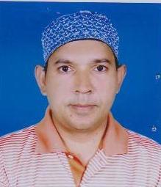 | DR. MD. MOFIZUL ISLAM TALUKDAR  F/Name: Late Dr. Mozzammel Hoque Talukdar  M/Name: Mosammad Shokina Begum  BM & DC Reg. No: 46170  NID: 3815838413861  Cell: 01718146300  Address: Zollesoritola, Newaz Living Center, Bogra.  Blood Group: O+
128 | Voter No  LM-0600128 | DR. DEBASHIS KUMAR GUPTA  F/Name: Rup Narayan Kanu  M/Name: Raj Kumari Debi  BM & DC Reg. No: 24681  NID: 1029407491010  Cell: 01716174090  Address: Doctors Quarter, 3rd floor, Mohammad Ali Hospital Campus, Bogra  Blood Group: O-
129 | Voter No  LM-0600129 | DR. A.T.M. BASHIR AHAMMAD  F/Name: Md. Abdul Majid  M/Name: Mrs. Hazera Khatun  BM & DC Reg. No: 33893  NID: 4644238901  Cell: 01715297491  Address: C/O- Dr. Md. Emdad Hossain,Shamsun Nahar Clinic, South Thanthania,Bogura  Blood Group: B+
130 | Voter No  LM-0600130  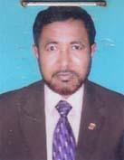 | DR. MD. JAHANGIR ALAM  F/Name: Md. Delmahmud  M/Name: Mst. Jasimannesa  BM & DC Reg. No: 12023  NID: 1022011093572  Cell: 01710814572  Address: Swapner Shiri, Paikerpara, Malothinagor, Bogra (Asstt. Professor.com. Medicine, Shaheed Ziaur Rahman Medical College, Bogra  Blood Group: B+
131 | Voter No  LM-0600131 | DR. A.K.M. AHSAN HABIB  F/Name: Md. Abul Hossain  M/Name: Mrs. Shahara Begum  BM & DC Reg. No: 19461  NID: 1022007059428  Cell: 01712062050  Address: Assistant Professor (Com.Med) Shaheed Ziaur Rahman Medical College, Bogra  Blood Group: B+
132 | Voter No  LM-0600132  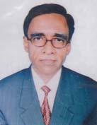 | DR. MD. RAFIQUL ISLAM  F/Name: Md. Abdur Razzak  M/Name: Late Mst. Rahima Khatun  BM & DC Reg. No: 15029  NID: 1022010241235  Cell: 01718785971  Address: Associate Professor of Medicine Shaheed Ziaur Rahman Medical College (SZMC)  Blood Group: O+
133 | Voter No  LM-0600133  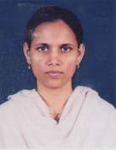 | DR. TAPASHI RAHMAN KHAN  F/Name: Bazlur Rahman Khan  M/Name: Rezia Khan  BM & DC Reg. No: 37881  NID: 1022010241234  Cell: 01715299388  Address: W/O- Dr. Md. Rafiqul Islam, Associate Prof. Of Medicine, SZMC, Bogra  Blood Group: B+
134 | Voter No  LM-0600134 | DR. MD. SAIDUR RAHMAN  F/Name: Md. Abdus Salam Mondol  M/Name: Late. Mst. Khoteza Begum  BM & DC Reg. No: 27129  NID: 1022008072198  Cell: 01715805050  Address: Registrar-Department of Skin & VD. Shaheed Ziaur Rhaman Medical College Hospital, Bogra  Blood Group: AB+
135 | Voter No  LM-0600135 | DR.SANAT KUMAR KUNDU  F/Name: Late Balaram Chandra Kundu  M/Name: Anima Bala Kundu  BM & DC Reg. No: 24655  NID: 1022014032041  Cell: 01711978263  Address: Medical Campus, SZMCH, Bogra.  Blood Group: A+
136 | Voter No  LM-0600136  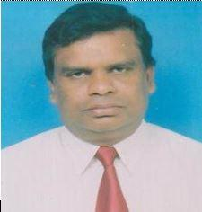 | DR. NISHIT KUMAR BISWAS  F/Name: Late. Dhireshwar Biswas  M/Name: Late. Kanchan Bala Biswas  BM & DC Reg. No: 11945  NID: 1022009082304  Cell: 01711123933  Address: Shaheed Ziaur Rahaman Medical College Hospital  Blood Group: O+
137 | Voter No  LM-0600137  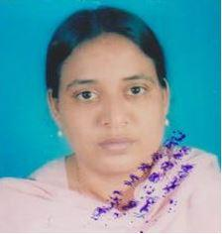 | DR. ZAKIA SULTANA CHOWDHURY  F/Name: C U Chowdhury  M/Name: Jahanara Begum  BM & DC Reg. No: 21087  NID:  Cell: 01712437377  Address: Hafizar Rahaman Road, Jaleswaritola, Bogra-5800  Blood Group: O+
138 | Voter No  LM-0600138  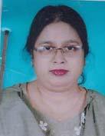 | DR. SHAMIMA AKHTER  F/Name: Late. Abdur Rahman  M/Name: Late. Nurjahan Begum  BM & DC Reg. No: 28234  NID: 1022010241505  Cell: 01712247333  Address: Doctor`s Park, 182/4, Koigari, Gohail Road, Bogura-5800.  Blood Group: O+
139 | Voter No  LM-0600139  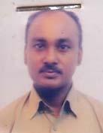 | DR. SUSHANTA KUMAR SARKAR  F/Name: Krishna Pada Sarkar  M/Name: Shanti Lota Sarkar  BM & DC Reg. No: 23672  NID: 2694814931490  Cell: 01711222350  Address: Male Dormitor, Shaheed Ziaur Rahman Medical College Hospital, Bogra  Blood Group: A+
140 | Voter No  LM-0600140  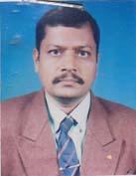 | DR. NARESH KUMAR ROY  F/Name: Monomohan Roy  M/Name: Ranjita Roy  BM & DC Reg. No: 17715  NID: 1029407321078  Cell: 01712032033  Address: Doctors Quarter (First Floor), Mohammad Ali Hospital, Bogra  Blood Group: B+
141 | Voter No  LM-0600141  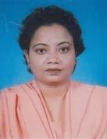 | DR. RATNA RANI SARKAR  F/Name: Bimal Chandra Sarkar  M/Name: Sreemati Nirmala Rani Sarkar  BM & DC Reg. No: 24368  NID: 1029407321080  Cell: 01712010756  Address: Doctors Quarter (First Floor), Mohammad Ali Hospital Bogra  Blood Group: B+
142 | Voter No  LM-0600142  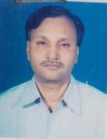 | DR. BIPUL CHANDRA ROY  F/Name: Bimalendu Roy  M/Name: Nilima Roy  BM & DC Reg. No: 10465  NID: 1022020198293  Cell: 01711875154  Address: Nataipara, Chellopara, Bogra  Blood Group: B+
143 | Voter No  LM-0600143  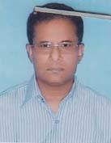 | DR. MD. MOKADDES HOSSAIN  F/Name: Late. Moqbul Hossain  M/Name: Golega Begum  BM & DC Reg. No: 11563  NID: 1022012104144  Cell: 01558335917  Address: Consultant Chest Diseases Mohammad Ali Hospital, Bogra  Blood Group: B+
144 | Voter No  LM-0600144  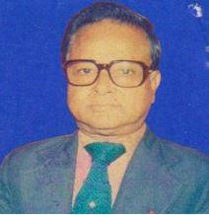 | PROF DR. MD. ABDUR RAHIM  F/Name: Dr E Ahmed  M/Name: MT Hamida Khatun  BM & DC Reg. No:  NID: 1022017168842  Cell:  Address: Dhorompur, Ne Mosque Bogra,5800  Blood Group: O+
145 | Voter No  LM-0600145  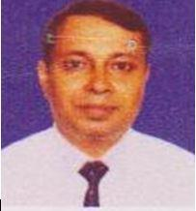 | DR. MOHAMMAD MAHBUB-UR RAHIM  F/Name: Prof (dr). Mohammad Abdur Rahim  M/Name: (late) Mrs.rahima Khatoon  BM & DC Reg. No: 25813  NID:  Cell: 01731573137  Address: CERP, East of Dhorompur Mosque, Paschimpara, Dhorompur, Bogra-5800  Blood Group: O+
146 | Voter No  LM-0600146  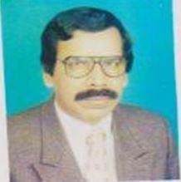 | DR. MD. RAZIQUL AHSAN  F/Name: Late Abul Quasem  M/Name:  BM & DC Reg. No:  NID:  Cell:  Address: Zacoan Medical Store, Nondigram, Bogra.  Blood Group:
147 | Voter No  LM-0600147  No Image | DR. AHMMMAD AL MUSTAFIZ  F/Name: Late Prof. Tariqul Alam  M/Name:  BM & DC Reg. No:  NID:  Cell: 01711876818.  Address: Malatonagar, Chanmari Ghat , Ahamad Ali Lane Bogra-5800.  Blood Group:
148 | Voter No  LM-0600148 | DR. NOUR ALAM  F/Name: Md. Momtajur Rahman  M/Name: Mrs. Rezia Begum  BM & DC Reg. No: 44575  NID: 1012034496869  Cell: 01712204772  Address: HCDP, Bogra  Blood Group: A+
149 | Voter No  LM-0600149  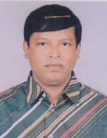 | DR. MD. TABIBUR RAHMAN  F/Name: Late. Abdul Jobbar  M/Name: Late. Tahmina  BM & DC Reg. No: 24526  NID: 1022008067741  Cell: 01711109494  Address: Shahid Abdul Bari Sarak Sutrapur, Bogra  Blood Group: O+
150 | Voter No  LM-0600150 | DR. SHAMEEM ARA BEGUM  F/Name: Late. Md. Hossain Ali Miah  M/Name: Mrs. Johura Hossain  BM & DC Reg. No: 29305  NID: 1018877077601  Cell: 01711014379  Address: Hospital Road, Sherpur, Bogra  Blood Group: B+
151 | Voter No  LM-0600151  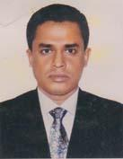 | DR. AMIRUL HOSSAIN CHOWDHURY  F/Name: Tofazzal Hossain Chowdhury  M/Name: Syeda Sharifa Khatun  BM & DC Reg. No: 18567  NID: 1018877077600  Cell: 01711378648  Address: Hospital Road, Sherpur, Bogra  Blood Group: O+
152 | Voter No  LM-0600152 | DR. MD. ABU HENA MAHMUD RUNU  F/Name: Md. Amir Ali  M/Name: Mrs. Mahfuza Khanoom  BM & DC Reg. No: 22488  NID: 1021131663  Cell: 01711359328  Address: D/5, Amicus Swapna Nir, Rahmannagar, Bogra  Blood Group: O+
153 | Voter No  LM-0600153 | DR. MD. ABDUL BATEN  F/Name: Md. Abdul Matin  M/Name: Mrs. Khadija Begum  BM & DC Reg. No: 32501  NID: 2697557419360  Cell: 01914602881  Address: Johurul Nagar, Bogra  Blood Group: B+
154 | Voter No  LM-0600154 | DR. HASNA JAHAN RUMA  F/Name: Md. Belayet Hossain  M/Name: Mrs. Moklema Khatun  BM & DC Reg. No: 26931  NID: 2393120551  Cell: 01715464633  Address: D/5, Amicus Swapnanir, Rahman Nagar, Bogra  Blood Group: A+
155 | Voter No  LM-0600155 | DR. GOPAL CHANDRA KARMAKAR  F/Name: Late: Nagendra Nath Karmakar  M/Name: Prova Rani Karmakar  BM & DC Reg. No: 20117  NID: 1022011101268  Cell: 01716113323  Address: Senior Medical Officer, Bangladesh Bank, Bogra  Blood Group: B+
156 | Voter No  LM-0600156  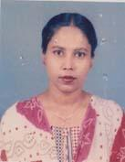 | DR. AMAAT-UL-HASIN  F/Name: Late. Akbar Ali  M/Name: Hasna Akbar  BM & DC Reg. No: 25692  NID: 1022003025868  Cell: 01711303183  Address: Alam Villa, Chandanbaisha Road, Nataipara, Bogra  Blood Group: n_a
157 | Voter No  LM-0600157 | DR. A.K.M TOWFIQUL ALAM  F/Name: Late. Assadud Dowla  M/Name: Late. Tahura Khanom  BM & DC Reg. No: 20585  NID: 1022003025879  Cell: 01712082396  Address: Alam villa, Chandan Baisha Road Nataipara, Bogra  Blood Group: O+
158 | Voter No  LM-0600158 | DR. SWAPNA RANI MONDAL  F/Name: Biswa Nath Mondal  M/Name: Suruchi Mondal  BM & DC Reg. No: 38186  NID: 2694814931494  Cell: 01717639019  Address: Asstt. Prof. Radiology & Imaging TMSS Medical College, Bogra  Blood Group: A+
159 | Voter No  LM-0600159  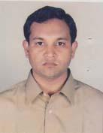 | DR. ABDULLAH AL BARI  F/Name: Muhammad Rafiqul Islam  M/Name: Mrs. Monnujan Islam  BM & DC Reg. No: 41832  NID: 2696654354373  Cell: 01711248997  Address: Silimpur West Para, Bogra Sadar, Bogra-5800  Blood Group: O+
160 | Voter No  LM-0600160 | DR. MD. GOLAM MOSTOFA  F/Name: Late. Md. Mohiuddin Mondal  M/Name: Late. Amena Beyoa  BM & DC Reg. No: 22681  NID: 1022005044594  Cell: 01759083330  Address: Assist. Prof. Dept. of Pediatrics Shaheed Ziaur Rahman Medical College  Blood Group: A+
161 | Voter No  LM-0600161 | DR. MD. SHAFIQUE AMIN KAJAL  F/Name: Prof. Alhaj Md. Abu Sayeed  M/Name: Mrs. Shahara Banu  BM & DC Reg. No: 45662  NID:  Cell: 01711108082  Address: C/A-1, Amin Mansion, Main Road, Uposhohor, Bogra  Blood Group: A+
162 | Voter No  LM-0600162 | DR. MAFRUHA JAHAN  F/Name: Md. Mokarram Hossain  M/Name: Mrs. Kamrun Layel Parvin  BM & DC Reg. No: 31455  NID: 2696406749397  Cell: 01766766610  Address: Asstt. Prof, Dept. Of Obs. & Gynae, Shaheed Ziaur Rahman Medical College Hospital  Blood Group: B+
163 | Voter No  LM-0600163  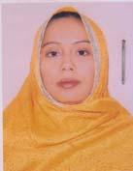 | DR. NAHIDA SULTANA  F/Name: Mokhlesar Rahman  M/Name: Selina Khatun  BM & DC Reg. No: 43983  NID: 2696352210509  Cell: 01717623436  Address: Mofiz Paglar Mor, Sherpur Road, Bogra  Blood Group: O+
164 | Voter No  LM-0600164 | DR. MD. ABDUL MAZID  F/Name: MD. NIZAM UDDIN AKAND  M/Name: Mst. Monowara Begum  BM & DC Reg. No: 34362  NID: 2696352210508  Cell: 01914123715  Address: Mofiz Paglar Mor, Sherpur Road, Bogra  Blood Group: O+
165 | Voter No  LM-0600165 | DR. MST. TOUHIDA SULTANA  F/Name: Late. Motahar Ali  M/Name: Sultana Rizia  BM & DC Reg. No: 28160  NID: 2697557398872  Cell: 01711109481  Address: Godhulia Kazikhana Lane, Rahman Nagar, Bogra  Blood Group: B+
166 | Voter No  LM-0600166 | DR. MD. REZAUL KARIM  F/Name: Alhaj. Md. Montejar Rahman  M/Name: Mrs. Momena Rahman  BM & DC Reg. No: 29708  NID:  Cell: 01711487477  Address: Shaheed Ziaur Rahman Medical College Hospital, Bogra  Blood Group: A+
167 | Voter No  LM-0600167  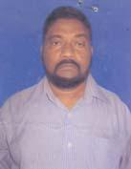 | DR. MD. RABIUL KARIM KHAN  F/Name: Late. Khajan Uddin Khan  M/Name: Late. Rahila Khondoker  BM & DC Reg. No: 11684  NID: 1022011249757  Cell: 01715819646  Address: Paikarpara, Malotinagar, Vaipagla Majar Lane, Bogra Sadar, Pouroshova, Bogra  Blood Group: A+
168 | Voter No  LM-0600168 | DR. AHMED ASHAFUDDOULA  F/Name: Ahmed Azimuddin  M/Name: Rokeya Begum  BM & DC Reg. No: 22455  NID:  Cell: 01711020847  Address: SZMC, Bogra  Blood Group: O+
169 | Voter No  LM-0600169  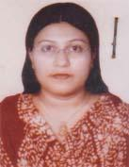 | DR. NOOR-E-AKHTER MUKTA  F/Name: Kazi Golam Akhter  M/Name: Begum Umme Taj  BM & DC Reg. No: 36155  NID: 1022009078372  Cell: 01712237325  Address: Shimi Bhaban, Khander, Gohail Road, Bogra  Blood Group: O-
170 | Voter No  LM-0600170 | DR. MD. MONIRUZZAMAN ASRAF BIPUL  F/Name: Md. Shahidul Islam  M/Name: Mst. Badrunnahar Alam  BM & DC Reg. No: 24950  NID: 1016721024710  Cell: 01711483853  Address: Shimi Bhabhan, Khandar, Gohail Road, Bogra  Blood Group: A+
171 | Voter No  LM-0600171  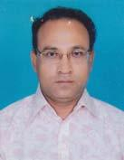 | DR. NITAI CHANDRA SARKAR  F/Name: Brojo Mohan Sarkar  M/Name: Shova Rani Sarkar  BM & DC Reg. No: 19801  NID: 8515849594463  Cell: 01711315915  Address: C.T. Clinic, Rahman Nagar, Bogra  Blood Group: AB+
172 | Voter No  LM-0600172 | DR. KISHOR KUMAR  F/Name: Amrita Chandra Das  M/Name: Maloti Rani  BM & DC Reg. No: 49954  NID:  Cell: 01730951354  Address: Chandmuha Haripur, Gokul, Bogra  Blood Group: B+
173 | Voter No  LM-0600173  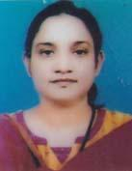 | DR. FAHMIDA HORKIL  F/Name: Md. Horkil Chowdhury  M/Name: Mrs. Asheka Chowdhury  BM & DC Reg. No: 27682  NID: 1022007058667  Cell: 01712275336  Address: Arif Chikitsa Kendra, Jaleswartitola, Bogra  Blood Group: B+
174 | Voter No  LM-0600174 | DR. MD. MOTARAB HOSSAIN  F/Name: Late. Moslem Uddin  M/Name: Mazeda Begum  BM & DC Reg. No: 23362  NID: 1022008073587  Cell: 01711301782  Address: Mohammad Ali Hospital-Bogra  Blood Group: B+
175 | Voter No  LM-0600175 | DR. MD. RAFIQUL ISLAM  F/Name: Late. Korban Ali  M/Name: Qulsum Begam  BM & DC Reg. No: 22893  NID: 1022011091632  Cell: 01711167088  Address: Arnob Villa, Maloti Nagar High School Road, Maloti Nagar, Bogra.  Blood Group: O+
176 | Voter No  LM-0600176 | DR. TAPOS KUMAR DAS  F/Name: Nishi Kanta Das  M/Name: Jutsna Das  BM & DC Reg. No: 19748  NID: 1022010085086  Cell: 01711879195  Address: Junior Consultant(Radiology & Imaging) 250 Beded, Mohammad Ali Hospital, Bogra.  Blood Group: B+
177 | Voter No  LM-0600177  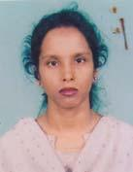 | DR. NIVA RANI DAS  F/Name: Nirendra Nath Das  M/Name: Bijoya Rani Das  BM & DC Reg. No: 37572  NID: 1022010085087  Cell: 01711900340  Address: Doctors Quarter Mohammad Ali Hospital, Bogra  Blood Group: O+
178 | Voter No  LM-0600178 | DR. F.N.M. GAUSUL HASAN  F/Name: Hares Uddin Ahmmad  M/Name: Bilkis Begum  BM & DC Reg. No: 39294  NID:  Cell: 01728360581  Address: C/O: Hares Uddin Ahmmad (Teacher), HB Tower, Vill+Post+P/S: Dupchanchia, Dist- Bogra  Blood Group: O+
179 | Voter No  LM-0600179 | DR. MD. AZIZUL HAQUE  F/Name: Md. Ismail Uddin Fakir  M/Name: Most. Jharna Begum  BM & DC Reg. No: 38693  NID:  Cell: 01712622225  Address: Vill: Atgram Poradaha, Post: Mostafapur (5880), Ps: Dupchanchia, Dist: Bogra  Blood Group: A+
180 | Voter No  LM-0600180  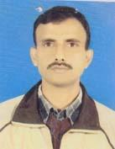 | DR. A T M NURUZZAMAN (SANCHOY)  F/Name: Md. Anowar Hossain Mandol  M/Name: Mst. Johura Begum  BM & DC Reg. No: 23822  NID: 1022008067238  Cell: 01711116490  Address: RMO, 250 Beded MA Hospital, Bogra  Blood Group: B+
181 | Voter No  LM-0600181  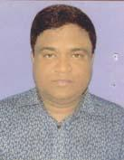 | DR. MD. ASHRAFUL HOQUE  F/Name: Md. Abul Hashem  M/Name: Mrs. Ashrafunnesa  BM & DC Reg. No: 47610  NID: 1022012111065  Cell: 01711134305  Address: Vill: Thantharia Dakkhinpara Ispahani-lane, PO: Bogra Sador, Dist: Bogra  Blood Group: A+
182 | Voter No  LM-0600182 | DR. MD. MAMUNUR RASHID SIDDIQUE  F/Name: Md. Mokbul Hossain  M/Name: Momenera Begum  BM & DC Reg. No: 39532  NID:  Cell: 01711317124  Address: "Kijukhan", Gohail Road, Koigare, Bogra  Blood Group: A+
183 | Voter No  LM-0600183  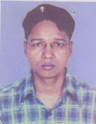 | DR. MD. AJMIRUL HOQUE SARKAR  F/Name: Md. Joynal Abedin Sarkar  M/Name: Mst. Afroza Begum  BM & DC Reg. No: 43724  NID: 2694803582811  Cell: 01717143446  Address: Khander, Gohail Road, Beside CRB Godown, Bogra.  Blood Group: A+
184 | Voter No  LM-0600184  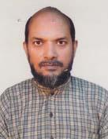 | DR. SYED SHAMIUL ALAM  F/Name: Late Syed Nurul Ahmed  M/Name: Late Rahima Khatun  BM & DC Reg. No: 10712  NID:  Cell: 01819665930  Address: Sultanganj Para, Bogra  Blood Group: O+
185 | Voter No  LM-0600185 | DR. MD. KHALILUR RAHMAN  F/Name: Late Jamir Uddin Mollah  M/Name: Mrs. Sufia Khatun  BM & DC Reg. No: 20901  NID: 1022010241308  Cell: 01734833404  Address: Rahman Nagar, Kazikhana lane, Bogra  Blood Group: A+
186 | Voter No  LM-0600186 | DR. MD. ABU TAHER  F/Name: Md. Abul Quasem  M/Name: Mrs. Hasna Banu  BM & DC Reg. No: 15282  NID: 9196201102549  Cell: 01735468789  Address: Naruli: P.O+Dist. Bogra  Blood Group: O+
187 | Voter No  LM-0600187 | DR. MD. ZAHIDUL KABIR  F/Name: Md. Zahurul Haque  M/Name: Mrs. Selina Akter  BM & DC Reg. No: 35429  NID: 1018156966133  Cell: 01727125698  Address: Dept of Orthosurgery, Shaheed Ziaur Rahman Medical College Hospital, Bogra  Blood Group: O+
188 | Voter No  LM-0600188 | DR. MD. ENAMUL HAQUE  F/Name: Md. Moslem Uddin Mollah  M/Name: Mst. Anwara Begum  BM & DC Reg. No: 36006  NID: 1022007062133  Cell: 01712206523  Address: Rahman Nagar, Bogra, MO. Shahid Ziaur Rahman Medical College Hospital  Blood Group: B+
189 | Voter No  LM-0600189  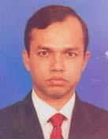 | DR. MD. HASAN ALI  F/Name: Md. Mozammal Hoque Pk.  M/Name: Mrs. Hasna Banu  BM & DC Reg. No: 36191  NID: 1022001008096  Cell: 01717325841  Address: House #06, Road #02, Nishindara, Upa-Shahor, Bogra  Blood Group: O+
190 | Voter No  LM-0600190  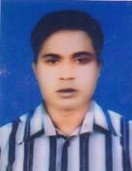 | DR. MD. NUR ALAM  F/Name: Md. Omar Faruk  M/Name: Mrs. Nurjahan Begum  BM & DC Reg. No: 52076  NID: 2650898260905  Cell: 01722894548  Address: Nayan Monjil, PO- Jahangirabad Canntt, Bogra.  Blood Group: A+
191 | Voter No  LM-0600191  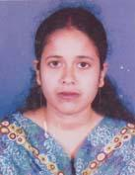 | DR. SUCHITA RANI GHOSH  F/Name: Sudhangshu Kumar Ghosh  M/Name: Ajantas Rani Ghosh  BM & DC Reg. No: 48434  NID: 8198510364367  Cell: 01718723033  Address: Vill-Kusumbi, P.O- Adamdighi, Thana- Adamdighi, Dist- Bogra  Blood Group: A+
192 | Voter No  LM-0600192 | DR. SANJOY KUMAR GHOSH  F/Name: Santosh Kumar Ghosh  M/Name: Bithi Rani Ghosh  BM & DC Reg. No: 41692  NID: 1010613079864  Cell: 01732148878  Address: Vill: Kusumbi, Thana+Post: Adamdighi, Dist: Bogra.  Blood Group: O+
193 | Voter No  LM-0600193 | DR. MD. MIZANUR RAHMAN  F/Name: Ahammed Hossain  M/Name: Most. Mina Begum  BM & DC Reg. No: 50623  NID: 1022008065848  Cell: 01717522781  Address: Sutrapur Central Eidgah Lane, Bogra  Blood Group: B+
194 | Voter No  LM-0600194 | DR. MD. ATAUR RAHMAN  F/Name: Late Md. Abdur Rab  M/Name: Mst. Mehrunnesa  BM & DC Reg. No: 11239  NID: 1022010086288  Cell: 01711425942  Address: Associate Professor (Pediatrics), Shahid Ziaur Rahman Medical College, Bogra  Blood Group: O+
195 | Voter No  LM-0600195 | DR. MD. AMINUL ISLAM  F/Name: Md. Ajijul Haque Bepari  M/Name: Most. Monoara Begum  BM & DC Reg. No: 34091  NID: 6919139810120  Cell: 01712502380  Address: Medical Officer, Shahid Ziaur Rahman Medical College Hospital, Bogra  Blood Group: AB+
196 | Voter No  LM-0600196 | DR. ABU ZAHED MD. FIROZ (LAYEL)  F/Name: Md. Nazim Uddin  M/Name: Mrs. Fojilatunnesa  BM & DC Reg. No: 33841  NID: 1022001008459  Cell: 01674614436  Address: 250 Beded Mohammad Ali Hospital, Bogra-5800  Blood Group: B+
197 | Voter No  LM-0600197 | DR. MD. BADRUL ANAM  F/Name: Md. Sadrul Anam  M/Name: Mrs. Firoza Anam  BM & DC Reg. No: 27583  NID: 1022010090352  Cell: 01711197556  Address: Anaesthe Riologist, Mohammad Ali Hospital, Bogra  Blood Group: B+
198 | Voter No  LM-0600198  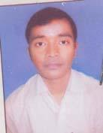 | DR. SANJAY KUMAR SARMOL  F/Name: Upendra Nath Mondal  M/Name: Shefaly Rani Sarker  BM & DC Reg. No: 51058  NID:  Cell: 01716727652  Address: SZMCH. Campus, Bogra  Blood Group: B+
199 | Voter No  LM-0600199 | DR. MD. RAKIBUL HASAN RASHED  F/Name: Md. Mazibar Rahman  M/Name: Most. Rehanatun Zinnath  BM & DC Reg. No: 39809  NID:  Cell: 01713731452  Address: Doctor's Quarter, SZMCH, Bogra.  Blood Group: A+
200 | Voter No  LM-0600200  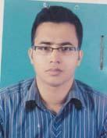 | DR. MD. RAJIBUR RAHMAN  F/Name: Md. Badiur Rahman  M/Name: Late. Lutfun Nahar  BM & DC Reg. No: 40527  NID: 2693624632247  Cell: 01711249505  Address: S.Z.M.C.H, Bogra, I.M.O, Medicine Unit I.  Blood Group: O+
201 | Voter No  LM-0600201 | DR. A.K.M. KHAIRUL BASHAR  F/Name: Md. Mahfuzar Rahman  M/Name: Mst. Delwara Begum  BM & DC Reg. No: 50605  NID: 1014081502251  Cell: 01716108351  Address: Lotifpur (Modhowpara), Shajahanpur, Bogra  Blood Group: O+
202 | Voter No  LM-0600202  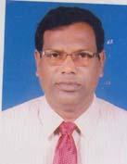 | DR. M. A. K. SHAMSUDDIN MINTU  F/Name: Late Samar Uddin Fakir  M/Name: Rahima Be  BM & DC Reg. No: 16505  NID: 1022011093477  Cell: 01711902694  Address: Mst. Prof. Orthopedics, Saheed Ziaur Rahman Medical College, Bogra  Blood Group: O+
203 | Voter No  LM-0600203  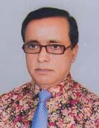 | DR. MD. ZAKIRUL ALAM  F/Name: Late Ramjan Ali  M/Name: Mrs. Jorina Bibi  BM & DC Reg. No: 14578  NID:  Cell: 01711869856  Address: C-5/Dolfin Towar, Joleshoritolla, Bogra  Blood Group: A+
204 | Voter No  LM-0600204 | DR. TAPAS KUMER TALUKDER  F/Name: Rabindra Nath Talukder  M/Name: Rekha Rani Talukder  BM & DC Reg. No: 22606  NID: 8816157668883  Cell: 01711359343  Address: Ayesha Ashraf Villa, Flat No- A5, Shaheed Khokon Sarak, Jaleswaritola, Bogura.  Blood Group: B+
205 | Voter No  LM-0600205  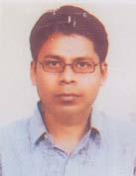 | DR. MILTON KUMER SAHA  F/Name: Dineswar Saha  M/Name: Mira Saha  BM & DC Reg. No: 42453  NID: 1028105454780  Cell: 01195171257  Address: Assistant Registrer, Orthosurgery, Shaheed Ziaur Rahman Medical College Hospital, Bogra  Blood Group: B+
206 | Voter No  LM-0600206 | DR. SYED SHAMSUL AREFIN  F/Name: Syed Golam Rahman  M/Name: Jannatul Ferdous  BM & DC Reg. No: 29228  NID: 1025406424005  Cell: 01712512371  Address: Maloti Nagar (Near MS Club), Bogra  Blood Group: O+
207 | Voter No  LM-0600207  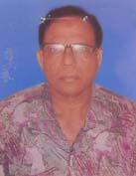 | DR. MOSTAFIZUR RAHMAN  F/Name: Abul Quasim Khan  M/Name: Mastarina Khatun  BM & DC Reg. No: 12579  NID: 1016710152678  Cell: 01819687053  Address: Upazilla Health Complex, Nandigram, Bogra  Blood Group: B+
208 | Voter No  LM-0600208 | DR. MD. MOBASHER-UR-RAHMAN  F/Name: Md. Mokhlesur Rahman  M/Name: Mahbuba Begum  BM & DC Reg. No: 25822  NID: 8198506402653  Cell: 01911971172  Address: Doctor\'s Quarter (Ground Floor), Mohammad Ali Hospital, Bogra  Blood Group: B+
209 | Voter No  LM-0600209 | DR. SHIBLY HAYDER  F/Name: Late Abdul Wahed  M/Name: Late Begum Rajiah Wahed  BM & DC Reg. No: 14958  NID: 2699238605123  Cell: 01711268070  Address: Department of Cardiology, SZMC Bogra  Blood Group: B+
210 | Voter No  LM-0600210 | DR. MD. SHAFIUL AZAM (BADSHA)  F/Name: Md. Moslem Uddin Sarker  M/Name: Mrs. Hasina Begum  BM & DC Reg. No: 41770  NID: 2693717170919  Cell: 01712061027  Address: Registrar, Surgery Department, Shaheed Ziaur Rahman Medical College Hospital, Bogra  Blood Group: B+
211 | Voter No  LM-0600211 | DR. MOHAMMAD ANWARUL ISLAM  F/Name: Dr. Noor Mohammad  M/Name: Rawshan Ara Begum  BM & DC Reg. No: 22485  NID: 1022001010143  Cell: 01911926886  Address: House No#1 (1st Floor), Road # 29, Housing Estate, Nishindara, Bogra  Blood Group: O+
212 | Voter No  LM-0600212 | DR. ASIM SARKAR  F/Name: Anil Chandra Sarkar  M/Name: Suvra Rani Sarkar  BM & DC Reg. No: 48200  NID:  Cell: 01712160884  Address: Vill: Goyabandha, PO: Talora, PS: Dupchanchia, Dist: Bogra  Blood Group: O+
213 | Voter No  LM-0600213  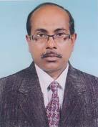 | DR. SHER MOSTAFA SADIQ KHAN  F/Name: Late Azmal Hossain Khan  M/Name: Late Sakina Khatun  BM & DC Reg. No: 3306  NID: 9326606061041  Cell: 01716093540  Address: Civil Surgeon Office, Bogra, Bangladesh  Blood Group: A+
214 | Voter No  LM-0600214 | DR. MD. MOKHLESUR RAHMAN  F/Name: Late Nazir Uddin Ahmed  M/Name: Late Asma Nasir  BM & DC Reg. No: 8808  NID: 1022001010733  Cell: 01712192676  Address: Vill: Afroza Tower Jaleswaritola, Nur Masjid Lane, Bogra.  Blood Group: A+
215 | Voter No  LM-0600215  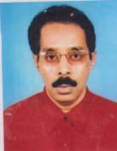 | DR. PARVEZ AHMED  F/Name: Sultan Uddin Ahmed  M/Name: Minu Ahmed  BM & DC Reg. No: 21018  NID: 1022011094364  Cell: 01711868246  Address: Malotinagar, Bogra  Blood Group: A+
216 | Voter No  LM-0600216 | DR. MD. ASHRAF ALI  F/Name: Md. Hyder Ali  M/Name: Begum Ayesha Khatoon  BM & DC Reg. No: 6803  NID: 2696653252782  Cell: 01713017404  Address: Doctors Clinic, Bogra Sherpur Road, Bogra  Blood Group: O+
217 | Voter No  LM-0600217 | DR. MD. IBNUL HASSAN RASEL  F/Name: Mr. Salique Ahmed  M/Name: Mrs. Sufia Ahmed  BM & DC Reg. No: 34142  NID:  Cell: 01711451820  Address: Gondogram, Ranirhat Road, Bogra  Blood Group:
218 | Voter No  LM-0600218 | DR. SYED MAHBUB HOSSAIN RAJIB  F/Name: Syed Magfur Hossain  M/Name: Nasima Begum  BM & DC Reg. No: 53417  NID: 1594116396925  Cell: 01717419270  Address: Rahman Nagar, Zillades Para, Doctor's Quarter  Blood Group: B+
219 | Voter No  LM-0600219 | DR. MD. ABUL KALAM AZAD  F/Name: Md. Azizar Rahman  M/Name: Mrs. Momena Khatun  BM & DC Reg. No: 28400  NID: 2691649424494  Cell: 01711220208  Address: Bogra Eye Care & Phaco Center, Moloya, 484/A Ray Bahadur Road, Jeleshshorytola Bogra.  Blood Group: O+
220 | Voter No  LM-0600220 | DR. MD. NAZRUL ISLAM BAKUL  F/Name: Late Dr. Jalal Uddin Ahmed  M/Name: Mst. Rizia Begum  BM & DC Reg. No: 18913  NID: 1022012114500  Cell: 01712260591  Address: Deptt. of Ortho-Surgery. Shaheed Ziaur Rahman Medical College, Bogra  Blood Group: O+
221 | Voter No  LM-0600221 | DR. A.K.M. MURADUZZAMAN  F/Name: Md. Cherag Uddin Chowdhury  M/Name: Mrs. Jahanara Begum  BM & DC Reg. No: 35764  NID: 1022009080123  Cell: 01714121343  Address: Khander, Gohail Road, Bogra Sadar, Bogra  Blood Group: O+
222 | Voter No  LM-0600222  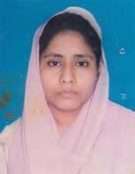 | DR. BABEE TILOTTOMA  F/Name: Kazi Liaquat Ali  M/Name: Mrs. Kaniz Fatema  BM & DC Reg. No: 39086  NID: 1022009080124  Cell: 01726257598  Address: Khander, Gohail Road, Bogra Sadar, Bogra.  Blood Group: A+
223 | Voter No  LM-0600223 | DR. SUROZIT KUMAR SARKAR  F/Name: Krishna Gopal Sarkar  M/Name: Chobi Rani Sarkar  BM & DC Reg. No: 39327  NID:  Cell: 01748915915  Address: Shibbati, Bogra Sadar, Bogra  Blood Group: B+
224 | Voter No  LM-0600224 | DR. MD. SHAHJAHAN ALI SARKER  F/Name: Late Khoshmamud Sarker  M/Name: Mrs. Jalimun Begum  BM & DC Reg. No: 9866  NID: 1022010086035  Cell: 01716964672  Address: Professor and Head Department of Anatomy, TMSS Medical College, Bogra  Blood Group: A+
225 | Voter No  LM-0600225 | DR. FARJANUL ISLAM NIRJHOR  F/Name: Dr. Nurul Islam  M/Name: N.a. Fazila Banu  BM & DC Reg. No: 51387  NID: 1022003240344  Cell: 01911327332  Address: C/O: Mostafa Jahangir, 2nd Floor, Kalitola Haat, Rangpur Road, Bogra  Blood Group: O+
226 | Voter No  LM-0600226 | DR. ANJIMA TAMIM METHELA  F/Name: Dr. Azfarul Habib  M/Name: Dr. Shams Shaela Banu  BM & DC Reg. No: 53242  NID: 1022007058642  Cell: 01717899125  Address: Jaleshwarytola, Bogra  Blood Group: B+
227 | Voter No  LM-0600227 | DR. AHMED AL MONTASIR  F/Name: Professor Dr. Matlub Ahmed  M/Name: Ayesha Khatun  BM & DC Reg. No: 33010  NID: 2694812106944  Cell: 01711483847  Address: Gohail Road, Sutrapur, Bogra  Blood Group: A+
228 | Voter No  LM-0600228  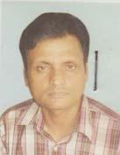 | DR. MD. REZWANUL BARI  F/Name: Md. Abbas Ali Mia  M/Name: Mrs. Rahena Banu  BM & DC Reg. No: 26298  NID: 19711022001000002  Cell: 01912990717  Address: 95, Ali Sonar Lane, Sultanganpara, Bogra  Blood Group: A+  E X P I R E D
229 | Voter No  LM-0600229 | DR. AKHTER-UL-ALAM AZAD  F/Name: S. M. Abul- Hossain  M/Name: Mst. Jahanara Begum  BM & DC Reg. No: 21833  NID: 1018877102416  Cell: 01711468598  Address: Vill: Hamsapur (Kataltola) PO: Shepur, Dist: Bogra  Blood Group: A+
230 | Voter No  LM-0600230  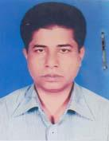 | DR. MD. ABDUL WAHED  F/Name: Md. Monsur Rahman  M/Name: Waheda Begum  BM & DC Reg. No: 28269  NID: 102940738878  Cell: 01713-228381  Address: Malotinagar, Bogra  Blood Group: B+
231 | Voter No  LM-0600231 | DR. MANABENDRA KUMAR PAUL NILOY  F/Name: Nil Madhab Paul  M/Name: Rita Rani Paul  BM & DC Reg. No: 52403  NID: 8524904043210  Cell: 01717018520  Address: Janoni House, Rahaman Nagar, Bogra  Blood Group: B+
232 | Voter No  LM-0600232 | DR. A. K. M. SHARIFUL REZWAN SHATIL  F/Name: A. K. M. Abdul Bari  M/Name: Mrs. Monowara  BM & DC Reg. No: 51338  NID:  Cell: 01711208153  Address: Majar Bari, Rahmannagar, Bogra  Blood Group: O+
233 | Voter No  LM-0600233 | DR. S.K. SHAJEDUL ALAM SUMON  F/Name: S. K. Nazrul Alam  M/Name: Mrs. Nurun Nahar Alam  BM & DC Reg. No: 39276  NID: 2698876354121  Cell: 01711208154  Address: Sutrapur, Bogra  Blood Group: O+
234 | Voter No  LM-0600234 | DR. ASHIM KUMAR SHAHA  F/Name: Amrita Lal Shaha  M/Name: Ashima Rani Shaha  BM & DC Reg. No: 41379  NID: 1022004034403  Cell: 01711130888  Address: Namazgare, Bogra  Blood Group: B+
235 | Voter No  LM-0600235  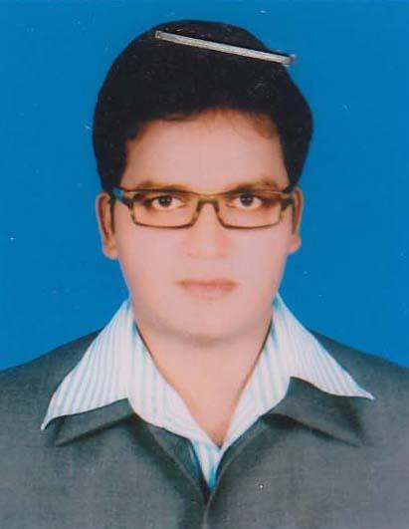 | DR. MD. AKHTER HOSSAIN  F/Name: Md. Abdul Khaleque  M/Name: Begum Shahnaj Akter  BM & DC Reg. No: 35580  NID: 2616880283064  Cell: 01713591783  Address: Sobuj Bagh Mosjid Lane, Bogra Sadar, Bogra.  Blood Group: A+
236 | Voter No  LM-0600236  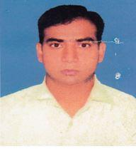 | DR. A.B.M ZAFAR SADIK  F/Name: Md. Mosabbar Ali Mondal  M/Name: Mrs. Anowara Begum  BM & DC Reg. No: 34249  NID: 1022014237575  Cell: 01711968436  Address: 5/E, Pallab Palace, Central Eidgah Link Road, sutrapur Bogra.  Blood Group: B+
237 | Voter No  LM-0600237  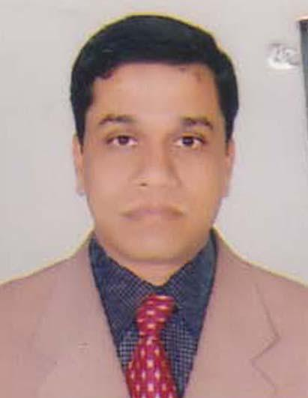 | DR. MD. ZAHIDUL ISLAM  F/Name: Md. Shofi Uddin  M/Name: Zahanara Begum  BM & DC Reg. No: 36875  NID: 4418044996764  Cell: 01712561771  Address: senior medical officer, NESCO Ltd. Bogura.  Blood Group: O+
238 | Voter No  LM-0600238  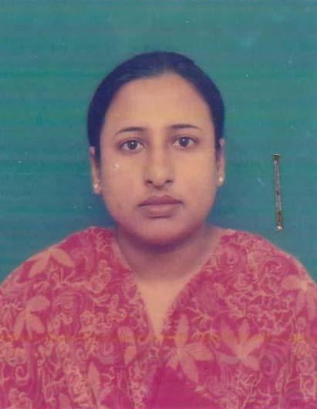 | DR. AFIFA HOSSAIN  F/Name: Late Md. Amzad Hossain Sardar  M/Name: Tanzima Begum  BM & DC Reg. No: 40694  NID: 1022003021920  Cell: 01911592867  Address: Kazi Villa Katnarpara, Coronation School Lane, Bogra.  Blood Group: B+
239 | Voter No  LM-0600239  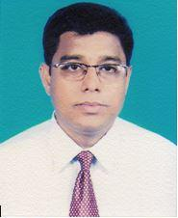 | DR. AHSANUL HUQ  F/Name: Dr. Md. Ataul Huq  M/Name: Dr. Amatul Naher Choudhury  BM & DC Reg. No: 53393  NID: 1022005045744  Cell: 01712772257  Address: HouseNo: 89/102, Enayet Ali Khan Lane, Katnarpara, Bogra-5800.  Blood Group: A+
240 | Voter No  LM-0600240  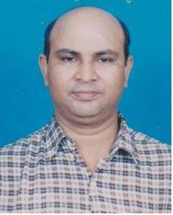 | DR. MD. ABUL KALAM AZAD  F/Name: Md. Shamsir Ali Mondal  M/Name:  BM & DC Reg. No:  NID:  Cell: 01712772257  Address: Asstt. Professor Dept. Of Surgery Shaheed Ziaur Rahaman Medical College, Bogra,  Blood Group:
241 | Voter No  LM-0600241  No Image | DR. MD. RAFIQUL ISLAM  F/Name: Md. Nazrul Islam  M/Name:  BM & DC Reg. No:  NID:  Cell:  Address: Asstt. Professor Dept Of Anasthesia Shaheed Ziaur Rahman Medical College Bogra.  Blood Group:
242 | Voter No  LM-0600242 | DR. MD. A. MOTTALAB HOSSAIN  F/Name: Md. Shafur Ali Mondal  M/Name:  BM & DC Reg. No:  NID:  Cell: 0711890815  Address: a  Blood Group:
243 | Voter No  LM-0600243  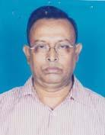 | DR. MD. ABDUL BARI  F/Name: Naser Ali  M/Name: Aklima  BM & DC Reg. No: 16698  NID: 6426002116962  Cell:  Address: Asst. Prof. of Orthopedics  Blood Group: A+
244 | Voter No  LM-0600244 | DR. MD. ABDUS SOBHAN  F/Name: Md. Amir Ali  M/Name:  BM & DC Reg. No:  NID:  Cell:  Address: Asst. Prof. of Surgery Dept. Shahid Ziaur Rahman Medical College Hospital, Bogura  Blood Group:
245 | Voter No  LM-0600245  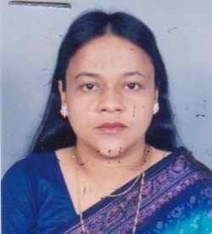 | DR. FARZANA SOHAEL  F/Name: Late Azizul Haque  M/Name:  BM & DC Reg. No:  NID:  Cell:  Address: Asst. Prof. Gynae & Obs Dept. Shaheed Ziaur Rahman Medical College Hospital. Bogura.  Blood Group: B+
246 | Voter No  LM-0600246  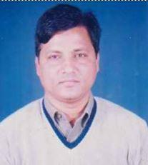 | DR. MD. ARIFUR RAHMAN  F/Name: Late Dr. Fazlur Rahman  M/Name:  BM & DC Reg. No:  NID:  Cell:  Address: Asst. Prof. Cardiology, Shaheed Ziaur Rahman Medical College Hospital, Bogura.  Blood Group:
247 | Voter No  LM-0600247  No Image | DR. MD. ALTAF HOSSAIN MONDOL  F/Name: Late. Azim Uddin Mondol  M/Name:  BM & DC Reg. No:  NID:  Cell:  Address: Asst. Prof. Psychiatry Dept. Shaheed Ziaur Rahman Medical College Hospital. Bogura.  Blood Group:
248 | Voter No  LM-0600248  No Image | DR. MD. REZAUL ISLAM  F/Name: Mr. Muin Uddin  M/Name:  BM & DC Reg. No:  NID:  Cell:  Address: Asstt. Prof. Of Child, Surgury Dept, Shanta Poli Clinic, Thonthonia, Bogra.  Blood Group:
249 | Voter No  LM-0600249  No Image | DR. MONOWARA KHATUN  F/Name:  M/Name:  BM & DC Reg. No:  NID:  Cell:  Address: Consultant, Gynae & OBS Dept. Shanta Poli Clinic, Thonthonia, Bogra.  Blood Group:
250 | Voter No  LM-0600250 | DR. MOHAMMAD SHAFIQUL HAQUE  F/Name: Md. Abdul Hakim  M/Name: Begum Sufia Hakim  BM & DC Reg. No: 17822  NID:  Cell: 01712045157  Address: Sara Hospital # 438, Paiker Mansion, Chalkjadu Road, Badurtola, Bogra  Blood Group: A+
251 | Voter No  LM-0600251 | DR. PANNA LAL SAHA  F/Name: Birendra Kumar Saha  M/Name: Purnima Rani Saha  BM & DC Reg. No: 35207  NID: 1022003027221  Cell: 01711587801  Address: M. O. Radiology & Imag Dept. MMCH  Blood Group: O+
252 | Voter No  LM-0600252  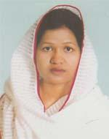 | DR. MST. SALMA SULTANA  F/Name: Md. Abdus Salam Bishwash  M/Name: Mrs. Fazilatunnesa  BM & DC Reg. No: 43706  NID: 2695044878953  Cell: 01714586267  Address: OSD, Dghs , Mohakhali, Dhaka  Blood Group: O-
253 | Voter No  LM-0600253  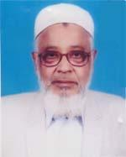 | DR. MD. FAZLUR RAHMAN  F/Name: Late Abul Kashem  M/Name: Late Saydun Nesa  BM & DC Reg. No: 6938  NID: 1022003031027  Cell: 01711062848  Address: UHC, DHUNAT, Bogra.  Blood Group: B+
254 | Voter No  LM-0600254 | DR. MD. ABUBAKER SIDDIQUE  F/Name: Dr. Md. Fazlur Rahman  M/Name: Mrs. Anwara Rahman  BM & DC Reg. No: 41343  NID: 2695044878934  Cell: 01711061012  Address: Sukh Niloy, Kainar Para, Bogra.  Blood Group: B+
255 | Voter No  LM-0600255 | DR. MD. ABU BAKAR SIDDIQUE  F/Name: Late Ayen Uddin Pk  M/Name: Late Nisa Bibi  BM & DC Reg. No: 32832  NID: 1022007062431  Cell: 01712243457  Address: Flat -A-1, Sadia Garden, Jaleswaritola, Bogra  Blood Group: A+
256 | Voter No  LM-0600256  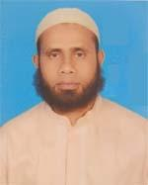 | DR. MD. JAHANGIR ALAM  F/Name: Md. Abdul Jabbar  M/Name: Jahanara Begum  BM & DC Reg. No: 41171  NID: 9419484183510  Cell: 01718018636  Address: Amikas Apartment, Kanuchagari, Bogra  Blood Group: A-
257 | Voter No  LM-0600257 | DR. ABU SALEH MD SADEQUL ISLAM  F/Name: Dr. MD SHAFIQUL ISLAM  M/Name: Samsun Nahar  BM & DC Reg. No: 36237  NID: 4644147508  Cell: 01712271441  Address: 3/A, Ghazi Marry Mension, Sutrapur, Bogra  Blood Group: A+
258 | Voter No  LM-0600258 | DR. MOHD. MOSADDEQUE HOSSAIN LOVELU  F/Name: Late Shamsuddin Mondol  M/Name: Monwara Begum  BM & DC Reg. No: 18838  NID: 2654070214859  Cell: 01711909864  Address: 20/1, Nabab Katra Neemtoli, Dhaka  Blood Group: B+
259 | Voter No  LM-0600259 | DR. MONISHA PRAMANIK  F/Name: Rabindra Nath Pramanik  M/Name: Maya Rani Pramanik  BM & DC Reg. No: 74626  NID: 19921022012000206  Cell: 01745759358  Address: Maya Kunjo, Latifpur South Para, Bogra Sadar, Bogra  Blood Group: B+
260 | Voter No  LM-0600260 | DR. MD. REZU AHMED  F/Name: Md. Shamsul Haque  M/Name: Mrs. Bilkis Begum  BM & DC Reg. No: 71328  NID: 1028513115778  Cell: 01737702611  Address: Vill-Latifpur, Maddhapara, Thana-Shajahanpur, Dist-Bogra  Blood Group: B+
261 | Voter No  LM-0600261 | DR. MUHAMMAD SWEET SHAHED KHAN  F/Name: Muhammad Shahed Ali Khan  M/Name: Late Tahera Khatun  BM & DC Reg. No: 40678  NID: 2691650154872  Cell: 01716606594  Address: Hazipara, Thanthania, Bogra Sadar, Bogra  Blood Group: A+
262 | Voter No  LM-0600262 | DR. SHAHLA SHAMMIN  F/Name: Md. Serajul Islam  M/Name: Jannatul Wadia  BM & DC Reg. No: 56651  NID: 1022010090176  Cell: 01716299188  Address: Thanthania, Hazipara, Bogra Sadar, Bogra  Blood Group: A+
263 | Voter No  LM-0600263 | DR. SHMARIA NOWRIN  F/Name: Dr. Md. Serajul Islam  M/Name: Dr. Tahmina Afroz  BM & DC Reg. No: 46345  NID: 19822696352220448  Cell: 01724403384  Address: Maleka Nursing Home, Sutrapur, Bogra, Bangladesh  Blood Group: B+
264 | Voter No  LM-0600264  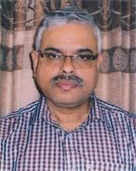 | DR. RABINDRA CHANDRA MITRA  F/Name: Late Bimal Chandra Mitra  M/Name: Parbati Mitra  BM & DC Reg. No: 14675  NID: 1022010241945  Cell: 01711312329  Address: DC. Banglow Lane, Malotinagar, Bogra  Blood Group: B+
265 | Voter No  LM-0600265 | DR. SITENDU SHEKHAR DAS  F/Name: Late Haripada Das  M/Name: Mrs. Kalyani Das  BM & DC Reg. No: 20975  NID: 1022020198004  Cell: 01715041936  Address: District Consultant FPCS-QIT, District Family Planning Office Joypurhat  Blood Group: AB+
266 | Voter No  LM-0600266  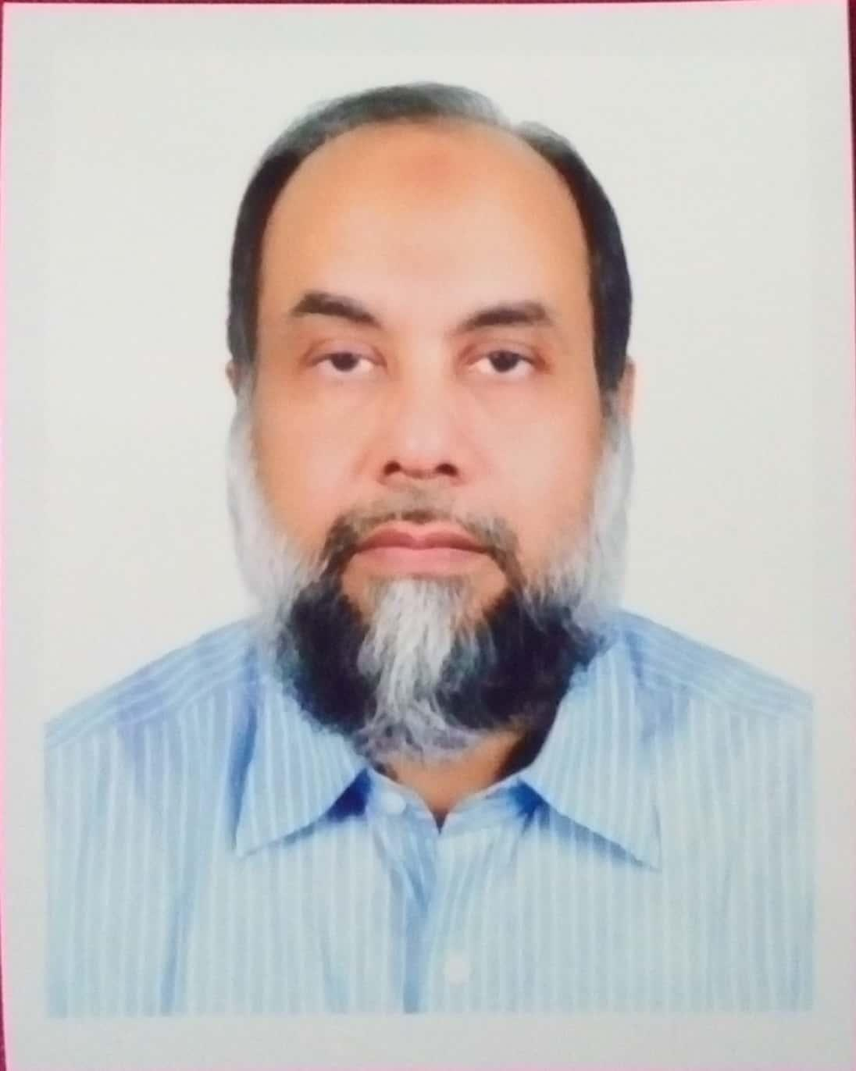 | DR.MD.ZILLUR RAHMAN  F/Name: Late Dr. Lutfur Raman  M/Name: Mst. Momotaz Begum  BM & DC Reg. No: 20639  NID: 1022010089421  Cell: 01979660079  Address: 68/5, Amicus Shopnoneer, Rahman Nagar, Bogra-5800  Blood Group: A+
267 | Voter No  LM-0600267  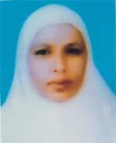 | DR. ROSY BEGUM  F/Name: Late Afzal Hossain  M/Name: Late Hurunnesa Hena  BM & DC Reg. No: 39959  NID: 1058598704769  Cell: 01732535373  Address: E 1/10 Nolik, Officers Accamodation Mayhira Cortt, Bogra  Blood Group: O+
268 | Voter No  LM-0600268 | DR. MD. ARIFUR RAHMAN TALUKDAR  F/Name: Md. Abdul Motin Talukdar  M/Name: Late Abtabun Nahar  BM & DC Reg. No: 41605  NID: 2694266784740  Cell: 01713462844  Address: C 6, Kohinur Villa, Noor Masjid Lane, Jaleswaritola, Bogura.  Blood Group: B+
269 | Voter No  LM-0600269  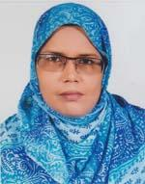 | DR. SHAKERA SULTANA  F/Name: Md. Yeasin Ali  M/Name: Amena Khatun  BM & DC Reg. No: 34308  NID: 1019415656104  Cell: 01712765762  Address: C 3, Century Vally, Riay Kagi Lane, Sutarpur, Bogra  Blood Group: O+
270 | Voter No  LM-0600270 | DR. S. M. ATIQUL ISLAM  F/Name: S. M. Nasir Uddin  M/Name: Mrs. Alefa Begum  BM & DC Reg. No: 36281  NID: 1016721020178  Cell: 01715784246  Address: House-11, Word-13, Kaigari, Bogra-5800  Blood Group: O+
271 | Voter No  LM-0600271  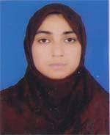 | DR. UMME KULSUM  F/Name: Md. Abdus Sobahan  M/Name: Momtaz Begum  BM & DC Reg. No: 47298  NID: 1028513118169  Cell: 01778953388  Address: House-11, Ward-13, Kaigari, Bogra  Blood Group: A+
272 | Voter No  LM-0600272 | DR. NAFIZ MD. MUSSABBIR HASAN  F/Name: Md. Matiur Rahman  M/Name: Nasima Akter  BM & DC Reg. No: 54722  NID: 1022007057449  Cell: 01731597161  Address: Khandakar Bari, Sutrapur, Reaz Kazi Lane, Bogra  Blood Group: O+
273 | Voter No  LM-0600273  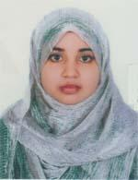 | DR. MOST. JANNATUL FERDAOUS  F/Name: Md. Balayet Hossain Talukder  M/Name: Most. Ajima Begum  BM & DC Reg. No: 61626  NID: 3817484713539  Cell: 01719346367  Address: Khandakar Bari, Riaz Kazi Lane, Sutrapur, Bogra  Blood Group: B+
274 | Voter No  LM-0600274 | DR. MD. ABDUS SALAM  F/Name: Safar Uddin Ahmed  M/Name: Zahera Khatun  BM & DC Reg. No: 22675  NID: 8829403756555  Cell: 01712011108  Address: 7 A, Momota Garden, Jawlesh /waritola, Chamsgu lane, Bogra  Blood Group: A+
275 | Voter No  LM-0600275 | DR. MD. NAJMUS SAADAT  F/Name: Dr. Md. Abdus Samad  M/Name: Mrs. Dilara Samad  BM & DC Reg. No: 54791  NID: 6125217236579  Cell: 01712678841  Address: House-31, Main Road, Uposhohor, Bogra  Blood Group: A+
276 | Voter No  LM-0600276 | DR. MD. NAJMUS SAKIB  F/Name: Dr. Md. Abdus Samad  M/Name: Mrs. Dilara Samad  BM & DC Reg. No: 47632  NID: 2196203131422  Cell: 01715299713  Address: House No.-31, Main Road, Uposhohor, Bogra  Blood Group: A+
277 | Voter No  LM-0600277 | DR. MUHAMMAD MAHMUDUL HAQUE  F/Name: Prof. A. K. M. Rashidul Haque  M/Name: Begum Mahmuda Haque  BM & DC Reg. No: 26598  NID: 8192226332833  Cell: 01715034972  Address: 250 Beded Mohammad Ali Hospital. Bogra  Blood Group: B+
278 | Voter No  LM-0600278 | DR. MD. ALI ASHRAF  F/Name: Late A. T. M. Najmul Haque  M/Name: Ms. Maleka Haque  BM & DC Reg. No: 23732  NID: 1022002017456  Cell: 01712549769  Address: Anchal Brindabon Para, Bogra  Blood Group: O+
279 | Voter No  LM-0600279 | DR. MD ZAHURUL ISLAM  F/Name: Abul Kashem Akond  M/Name: Zobeda Begum  BM & DC Reg. No: 17055  NID: 1022007059171  Cell: 01715551900  Address: Comfort View, S. Chaterjee Lane, Jaleswaritala, Bogra  Blood Group: B+
280 | Voter No  LM-0600280  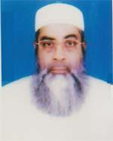 | DR. S. A. S. MD. ABDUL BAQUI  F/Name: Sk. Md. Izzatullah  M/Name: Saleha Khatun  BM & DC Reg. No: 5808  NID: 1022010090907  Cell: 01712512257  Address: Thanthania, Sherpur Road, Bogra  Blood Group: O+
281 | Voter No  LM-0600281 | DR. MOSTAFA KAMAL SHAPON  F/Name: Md. Abdul Jalil  M/Name: Mst. Mahmuda Khatun  BM & DC Reg. No: 30711  NID: 19741022012114486  Cell: 01734041730  Address: Thanthania , Bogra  Blood Group: B+
282 | Voter No  LM-0600282 | DR. MD. ABDUL MANNAN  F/Name: Late Abdul Mojid Mollah  M/Name: Late Katamon Bibi  BM & DC Reg. No: 26203  NID: 3743717112  Cell: 01712005299  Address: Flat- C/2, Dolphin Tower, Jaleswaritola, Bogura.  Blood Group: O+
283 | Voter No  LM-0600283 | DR. ALOK CHANDRA SARKER  F/Name: Late Golokeshwar Sarker  M/Name: Parul Rani Sarker  BM & DC Reg. No: 28016  NID: 19733222401102018  Cell: 01712414434  Address: 6# B, Gazi Real Estate LTD. Baxi Bazar, Bogra  Blood Group: B+
284 | Voter No  LM-0600284  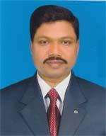 | DR. MD. REZAUL KARIM SARKER  F/Name: Late Nazab Uddin Sarker  M/Name: Late Rahima Khatun  BM & DC Reg. No: 18906  NID: 1022007058007  Cell: 01712503079  Address: Sabujbug, Bogra  Blood Group: O+
285 | Voter No  LM-0600285  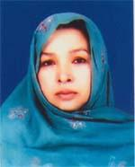 | DR. MST. SABERA SULTANA  F/Name: Late Md. Salek  M/Name: Mst. Akhterun Nesa  BM & DC Reg. No: 20146  NID: 1022007057652  Cell: 01916820906  Address: Sabujbag, Bogra  Blood Group: B+
286 | Voter No  LM-0600286 | DR. SUPROTIK GHAGRA  F/Name: Shoshibhuson Dio  M/Name: Nayami Ghagra  BM & DC Reg. No: 27567  NID: 7341214000  Cell: 01712918375  Address: Bogra Christian Mission Hospital, Gohail Road, Bogra-5800  Blood Group: O+
287 | Voter No  LM-0600287 | DR. RITA MANDAL  F/Name: Sudash Kumar Biswas  M/Name: Rebeca Biswas  BM & DC Reg. No: 23454  NID: 1022009079296  Cell: 01713368384  Address: Christian Mission Hospital, Bogra  Blood Group: B+
288 | Voter No  LM-0600288 | DR. MD. REZAUL KARIM  F/Name: Md. Abdus Samad  M/Name: Mrs. Khodeza Begum  BM & DC Reg. No: 19913  NID: 26950448837665  Cell: 01715032431  Address: Assistant Professor, Urology, Shaheed Ziaur Rahman Medical College Bogra.  Blood Group: A+
289 | Voter No  LM-0600289 | DR. MD. KAMAL HOSSEN  F/Name: Md. Khademul Islam  M/Name: Mst. Humayra Begum  BM & DC Reg. No: 46394  NID: 6919171893984  Cell: 01712218880  Address: Rahmannagar, Nandigram , Bogra  Blood Group: B+
290 | Voter No  LM-0600290  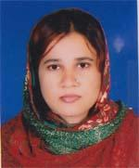 | DR. MST. UMME SALMA JANNATI  F/Name: Late Mozaharul Alam  M/Name: A. K. M Rina Laila Begum  BM & DC Reg. No: 36007  NID: 1022007062134  Cell: 01734526317  Address: Shahid Khokon Road, Jales Waritola, Bogra, House Name Manha  Blood Group: O+
291 | Voter No  LM-0600291 | DR. MD. KAMAL HOSSAIN  F/Name: Md. Shamsul Haque  M/Name: Mrs. Kohinoor Begum  BM & DC Reg. No: 33365  NID: 2690243429193  Cell: 01816343368  Address: Khan Lodge, Gohail Road, Sutrapur, Bogra  Blood Group: A+
292 | Voter No  LM-0600292  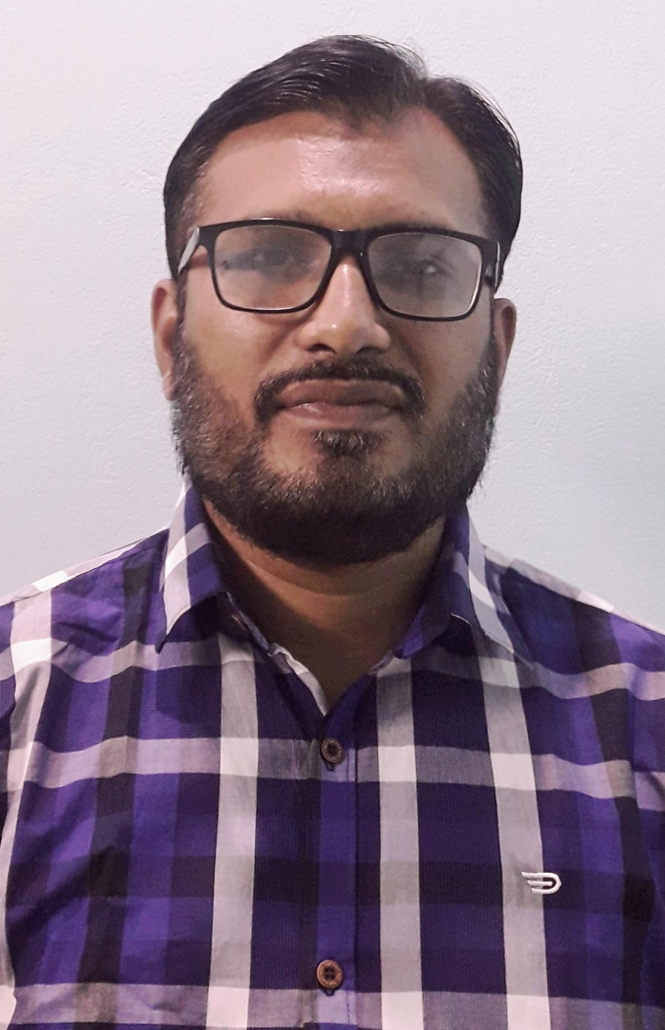 | DR. MD. MEHEDI HASAN  F/Name: Md. Abed Ali  M/Name: Mst. Shahera Abed  BM & DC Reg. No: 45943  NID: 19821028514246628  Cell: 01919680203  Address: Shakpala South Para, Ward # 14, Bogla Paurashava, Bogra  Blood Group: B+
293 | Voter No  LM-0600293 | DR. ZUBAIDUL HAQUE  F/Name: Mohammad Ali  M/Name: Zorina Begum  BM & DC Reg. No: 34587  NID: 1022020197408  Cell: 01912239989  Address: Shafi Clinic, Naruli, Bogra  Blood Group: B+
294 | Voter No  LM-0600294 | DR. UMMA HANI  F/Name: Dr. Md. Saiduzzaman  M/Name: Mrs. Nurjahan Zaman  BM & DC Reg. No: 47518  NID: 19791022020197676  Cell: 01911267553  Address: Shati Clinic, Naruli, Bogra  Blood Group: B+
295 | Voter No  LM-0600295 | DR. TONMOY BURMON  F/Name: Dr. Biplob Kumar Burmon  M/Name: Kanak Lata Saha  BM & DC Reg. No: 62661  NID: 1028808704140  Cell: 01722688002  Address: UHC, Dhunat, Bogra  Blood Group: A+
296 | Voter No  LM-0600296 | DR. NUSRAT JAHAN MOUSHUMI  F/Name: Md. Abdul Momen  M/Name: Mrs. Ribon  BM & DC Reg. No: 61589  NID: 1022008065577  Cell: 01737828474  Address: Reaj Kazy Lane, Sutrapur, Bogra  Blood Group: A+
297 | Voter No  LM-0600297  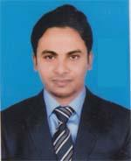 | DR. MD. ABDUL ALIM  F/Name: Md. Khourshed Alam  M/Name: Shuli Khatun  BM & DC Reg. No: 71003  NID: 8815017754460  Cell: 01780740057  Address: R.D.A, Rahmannagar, Sherpur, Bogra  Blood Group: A+
298 | Voter No  LM-0600298 | DR. A. N. M. EHSANUL KARIM  F/Name: Nasir Uddin Ahmed  M/Name: Saleha Khatun  BM & DC Reg. No: 27069  NID: 2695435979054  Cell: 01819251431  Address: SP Banglow Lane, Maloti Nagar, Bogra-5800  Blood Group: A+
299 | Voter No  LM-0600299  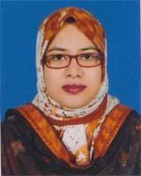 | DR. GOLSHAN ARA MARJAN  F/Name: Dr. Md. Golam Hossain  M/Name: Saleha Hossain  BM & DC Reg. No: 41507  NID: 2695435979053  Cell: 01729251431  Address: SP Banglow Lane, Maloti Nagar, Bogra-5800  Blood Group: O+
300 | Voter No  LM-0600300  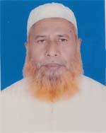 | DR. MD. GOLAM HOSSAIN  F/Name: Late Asgar Ali  M/Name: Mrs. Raumicha Khatun  BM & DC Reg. No: 8947  NID: 1022011101299  Cell: 01814902130  Address: Malti Nagar, Bogra Sadar, Bogra  Blood Group: O+
301 | Voter No  LM-0600301  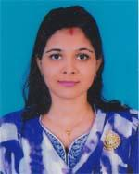 | DR. PRIANKA SAHA  F/Name: Nishi Kanta Saha  M/Name: Pallabi Saha  BM & DC Reg. No: 72980  NID: 19911010667000227  Cell: 01746498890  Address: Burmon Health Care, Sannyl Para Sherpur, Bogra  Blood Group: AB+
302 | Voter No  LM-0600302 | DR. AMIT KUMAR LAHA  F/Name: Abinash Chandra Laha  M/Name: Latika Laha  BM & DC Reg. No: 59153  NID: 1028802623146  Cell: 01717523212  Address: Vil-Duttapara, Post-Sherpur, Thana-Sherpur, Dist-Bogra  Blood Group: O+
303 | Voter No  LM-0600303 | DR. ANKITA DHAR  F/Name: Atul Kumar Dhar  M/Name: Shikha Dhar  BM & DC Reg. No: 53985  NID: 9196203120570  Cell: 01715066249  Address: Dhunat UHC, Dhunat, Bogra  Blood Group: O+
304 | Voter No  LM-0600304 | DR. MD. MOHIUDDIN ASLAM  F/Name: Md. Abdul Mazid  M/Name: Mrs. Aklima Begum  BM & DC Reg. No: 30098  NID: 1022012108701  Cell: 01711968630  Address: M.S. Club Math Lane, Malotinagar, Bogura.  Blood Group: B-
305 | Voter No  LM-0600305  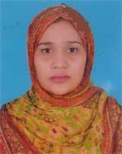 | DR. KANIJ FARHANA  F/Name: Md. Abul Bashar  M/Name: Begum Hosna Ara  BM & DC Reg. No: 56611  NID: 8198510364045  Cell: 01717451742  Address: Shajher Maya, Vill-Purba Koigari, P.s-Shajahanpur, Post-Bogra Sadar, Dist-Bogra  Blood Group: B+
306 | Voter No  LM-0600306 | DR. A.S.M.SELIM  F/Name: Md. Saber Ali Sarder  M/Name: Mrs. Selina Begum  BM & DC Reg. No: 49534  NID: 1010627930950  Cell: 01717564073  Address: Gohail Road, Khandar, Bogra Sadar, Bogra  Blood Group: AB+
307 | Voter No  LM-0600307  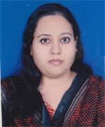 | DR. HABIBA TUN NESSA  F/Name: Md. Habibur Rhaman  M/Name: Alhamra Begum  BM & DC Reg. No: 58789  NID: 6886014601  Cell: 01845005341  Address: Gohail Road, Khandar , Bogra  Blood Group: B+
308 | Voter No  LM-0600308  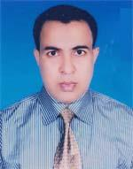 | DR. ABU SALEH DIN MUHAMMAD  F/Name: Md. Abdur Rauf Sarkar  M/Name: Md. Hazera Begum  BM & DC Reg. No: 33110  NID: 1022016157381  Cell: 01712292296  Address: Nishindara Maddhapara, Bogra  Blood Group: B+
309 | Voter No  LM-0600309  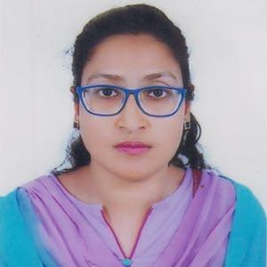 | DR. SHOHELE SULTANA MITHUN  F/Name: Late Masudur Rahman  M/Name: Aktar Banu Rahman  BM & DC Reg. No: 53350  NID: 1022004031960  Cell: 01753586872  Address: Konika Kunja, South East Naruli, Bogra Sadar, Bogra  Blood Group: A+
310 | Voter No  LM-0600310 | DR. MD. MOSLEH UDDIN HAIDER (RUSSEL)  F/Name: Md. Mozahar Hossain  M/Name: U. H. M. Rezia Begum  BM & DC Reg. No: 41910  NID: 2690417547628  Cell: 01711238250  Address: Jalossharitola, Bogra  Blood Group: B+
311 | Voter No  LM-0600311  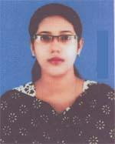 | DR. FEROJA BANU SHERIN  F/Name: Md. Mostafizur Rahman  M/Name: Mrs. Momotaz Begum  BM & DC Reg. No: 42247  NID: 19812690417547627  Cell: 01726102491  Address: Jolossharitola, Bogra  Blood Group: AB+
312 | Voter No  LM-0600312 | DR. MST. AREFIN ZANNAT  F/Name: Md. Abdul Hannan Talukder  M/Name: Mst. Ayesha Khatun  BM & DC Reg. No: 63066  NID: 1022004244066  Cell: 01717999744  Address: Koigari, East side of Fishery office, Bogra-5800  Blood Group: B+
313 | Voter No  LM-0600313  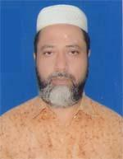 | DR. F. M. MUSA AL MANSUR  F/Name: Md. Ekram Hossain  M/Name: Most. Fazilatun Nessa  BM & DC Reg. No: 17377  NID: 1022003241143  Cell: 01793119128  Address: Upazilla Health Complex, Shibganj, Bogra  Blood Group: O+
314 | Voter No  LM-0600314  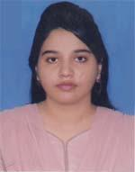 | DR. SADIA AHMED  F/Name: Nazim Uddin Ahmed  M/Name: Mst. Selina Begum  BM & DC Reg. No: 69037  NID: 19918192224000016  Cell: 01723632807  Address: Riaz Kazi Lane, Sutrapur, Bogra  Blood Group: A+
315 | Voter No  LM-0600315 | DR. NAGIB MAHBUB  F/Name: Mahabubur Rahman  M/Name: Dr. Nurun Nahar  BM & DC Reg. No: 49570  NID: 19831022009078019  Cell: 01711784246  Address: Riaz Kazi Lane, Sutrapur, Bogra  Blood Group: A+
316 | Voter No  LM-0600316  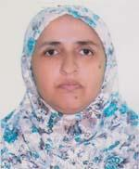 | DR. MOST. AFROZA SARKAR  F/Name: Md. Aftab Uddin Sarkar  M/Name: Most. Selina Akter  BM & DC Reg. No: 23438  NID: 1022003241144  Cell: 01855687084  Address: 250 Bed Mohammad Ali Hospital, Bogra  Blood Group: O+
317 | Voter No  LM-0600317  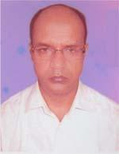 | DR. MD. ABUL FAZAL  F/Name: Late Md. Abdul Jabbar  M/Name: Sufia Begum  BM & DC Reg. No: 22947  NID: 19671022016000002  Cell: 01715307346  Address: Upazilla Health Complex, Kahaloo, Bogra  Blood Group: O+
318 | Voter No  LM-0600318 | DR. MD. HABIBUR RAHMAN  F/Name: Late Sona Ullah Mondol  M/Name: Most. Halima Khatun  BM & DC Reg. No: 25614  NID: 509 443 7091  Cell: 01711468533  Address: Vill-Natai Para, P.s+Dist-Bogra  Blood Group: O+
319 | Voter No  LM-0600319 | DR. ALI AHMED  F/Name: Suruz Ali  M/Name: Joytun Bibi  BM & DC Reg. No: 27279  NID: 1022004033011  Cell: 01719549584  Address: Zohurul Nagar, Bogra  Blood Group: O+
320 | Voter No  LM-0600320 | DR. MD. MOSTAFIZUR RAHMAN  F/Name: Fazlur Rahman  M/Name: Misses Nur-un-nahar  BM & DC Reg. No: 35440  NID: 19751028513234166  Cell: 01714380620  Address: Doctor's Quarter, Mohammad Ali Hospital Campus, Bogra.  Blood Group: B+
321 | Voter No  LM-0600321  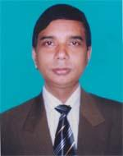 | DR. SUBIMAL SANKAR SAHA  F/Name: Late Suprovat Sankar Saha  M/Name: Urmila Rani Saha  BM & DC Reg. No: 21891  NID: 1022003027731  Cell: 01711301466  Address: Saha Complex, Jhowtala, Bogra  Blood Group: A+
322 | Voter No  LM-0600322  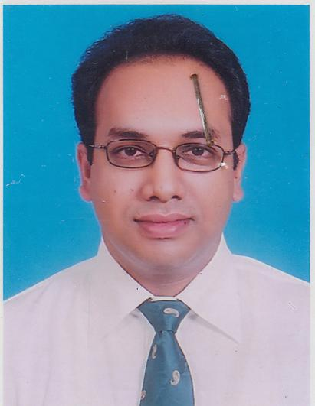 | DR. MD. ZAKIRUL ISLAM  F/Name: Late Abdul Latif Pk  M/Name: Zobeda Begum  BM & DC Reg. No: 30555  NID: 1012766052710  Cell: 01748994027  Address: Moyez Miar Baganbari, Kanosgari, Bogra  Blood Group: AB+
323 | Voter No  LM-0600323  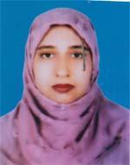 | DR. ANJUMAN ARA  F/Name: Sk. Fohom Uddin  M/Name: Seharunnesa  BM & DC Reg. No: 29784  NID: 2694263708078  Cell: 01819181062  Address: Moyez Miar Baganbari, Konosgari, Sherpur Road, Bogra  Blood Group: B+
324 | Voter No  LM-0600324 | DR. MD. ABDUL AWAL  F/Name: Md. Abdur Rashid  M/Name: Mrs. Rahima Begum  BM & DC Reg. No: 28177  NID: 1022012112524  Cell: 01712070998  Address: Director, Institute Of Nuclear Medicine and Allied Science, Bogra.  Blood Group: B+
325 | Voter No  LM-0600325  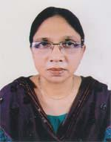 | DR. SHARMINA PERVIN  F/Name: Saifuddin  M/Name: Firoza Begum  BM & DC Reg. No: 24551  NID: 1022010089433  Cell: 01711128901  Address: "Amicus Shopnoneer" Rahaman Nagar Kazi Khana Road, Bogra.  Blood Group: O+
326 | Voter No  LM-0600326  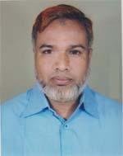 | DR.BELAL UDDIN  F/Name: Azizul Haque  M/Name: Dil Afroz Banu  BM & DC Reg. No: 20092  NID: 1022010089432  Cell: 01711413380  Address: Amicus Shopno Neer`,Rahman Nagor, Kazi Khana Road, Bogura  Blood Group: O+
327 | Voter No  LM-0600327 | DR. MD. SAIFUR RAHMAN SHAHEEN  F/Name: Md. Saidur Rahman  M/Name: Mst. Shihara Begum  BM & DC Reg. No: 33983  NID: 1022005044115  Cell: 01711467176  Address: 6(I), Pollob Palace , Central Eid Gah Lane, Suttrapur, Bogra  Blood Group: A-
328 | Voter No  LM-0600328 | DR. MOST. RUNA PARVIN  F/Name: Md. Abdul Halim  M/Name: Most. Hawa Begum  BM & DC Reg. No: 33984  NID: 1022005044116  Cell: 01711066670  Address: 6(I) , Pollob Palace , Eid Gah Lane, Suttrapur, Bogra  Blood Group: B-
329 | Voter No  LM-0600329  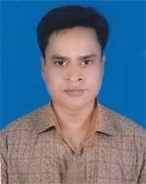 | DR. S. M. MAHMUDUR RASHID  F/Name: Late Mofiz Uddin  M/Name: Late Jahanara Begum  BM & DC Reg. No: 40120  NID: 2698879402491  Cell: 01914255466  Address: Mohammad Ali Hospital, Bogra  Blood Group: B+
330 | Voter No  LM-0600330 | DR. BEAUTY BEGUM  F/Name: Md. Azmat Ali  M/Name: Mrs. Laila Begum  BM & DC Reg. No: 40118  NID: 2698879402443  Cell: 01914799624  Address: Mohammad Ali Hospital, Bogra  Blood Group: B+
331 | Voter No  LM-0600331 | DR. MONOGNA CHITRALEKHA KUNDU  F/Name: Dilip Kumar Kundu  M/Name: Jharna Kundu  BM & DC Reg. No: 32621  NID: 2726408170525  Cell: 01712504733  Address: Doctor's Staff Quater , 250 Beded Mohammad Ali Hospital , Bogra  Blood Group: B+
332 | Voter No  LM-0600332 | DR. MD. SIDDIQUR RAHMAN  F/Name: Mohsin Ali  M/Name: Rokeya Begum  BM & DC Reg. No: 13521  NID: 1022010241502  Cell: 01711425966  Address: B-3, Amicus, Swapnonir, Kazi Khan Road, Rahman Nagar, Bogra  Blood Group: A+
333 | Voter No  LM-0600333 | DR. MD. SHAH NAWAZ  F/Name: Zali Mvi. Shams Uddin Ahmed  M/Name: Zali Nurun Nahar  BM & DC Reg. No: 14718  NID: 1022007060354  Cell: 01711313793  Address: House. No.-11, Road No.-8, Jan-E-Sheba Housing Complex, Station Road, Bogra  Blood Group: B+
334 | Voter No  LM-0600334 | DR. MD. REZAUL KARIM  F/Name: Md. Sekendar Ali Mondal  M/Name: Mst. Romisa Begum  BM & DC Reg. No: 30900  NID: 1029403326492  Cell: 01718785150  Address: Idris khan Lane, Badurtala, Bogra  Blood Group: B+
335 | Voter No  LM-0600335  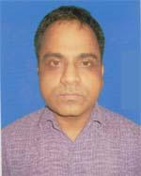 | DR. MD. FAZLUL HAQUE  F/Name: Md. Mozaffar Hossain Khan  M/Name: Mst. Ramisa Khatun  BM & DC Reg. No: 34707  NID: 1012785237867  Cell: 01712470261  Address: Vill-Khaduli, Post-Pirhati, Dhunat, Bogra  Blood Group: B+
336 | Voter No  LM-0600336  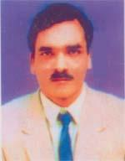 | DR. MD. SHAFIQUL KARIM TALUKDER  F/Name: Late Abdul Karim Talukder  M/Name: Zohura Begom  BM & DC Reg. No: 17706  NID: 1013367716888  Cell: 01711135482  Address: Ameda Manson, Rahman Nagor, Bogra  Blood Group: AB+
337 | Voter No  LM-0600337 | DR. S. M. ABDUL MUNIM  F/Name: Md. Osman Ali Sarder  M/Name: Most. Tauhida Begum  BM & DC Reg. No: 40989  NID: 3821303303080  Cell: 01716773065  Address: 1/4, Doctor's Quarter Shahid Ziaur Rahman Medical College Hospital, Bogra.  Blood Group: B+
338 | Voter No  LM-0600338  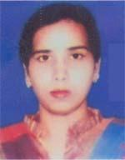 | DR. ZAKIA SULTANA  F/Name: Md. Alim Uddin Khandker  M/Name: Lutfun Nahar  BM & DC Reg. No: 49884  NID: 1022010085617  Cell: 01712782728  Address: 50-Comfort Garden, Riaz Kazi Lane, Sutrapur, Bogra  Blood Group: A+
339 | Voter No  LM-0600339 | MD. ISFAQUR RAHMAN  F/Name: Late Habibur Rahman  M/Name: Late Mahubaba Begum  BM & DC Reg. No: 18722  NID: 1021044605  Cell: 01711110550  Address: 50-Comfort Garden, Riaz Kazi Lane, Sutrapur, Bogra  Blood Group: O+
340 | Voter No  LM-0600340 | DR. MD. MUNSUR RAHMAN  F/Name: Late Abbas Ali Sk.  M/Name: Mrs. Shahebjan Bibi  BM & DC Reg. No: 23024  NID: 6410363961220  Cell: 01715299394  Address: Junior Consultant (Ophthalmology) UHC, Adamdighi, Bogra.  Blood Group: O+
341 | Voter No  LM-0600341 | DR. MD. MAHBUB HOSSAIN SARDER  F/Name: Md. Mokbul Hossain Sarder  M/Name: Nurun Nahar Begum  BM & DC Reg. No: 47541  NID: 1020606096540  Cell: 01920735949  Address: Post Office Para, Post-Santahar, P.s-Adamdighi, Dist-Bogra.  Blood Group: B+
342 | Voter No  LM-0600342 | DR. MEHER HUR RAHMAN (BRISTY)  F/Name: Md. Musta Fizur Rahman  M/Name: Salma Rahman  BM & DC Reg. No: 62130  NID: 1022011093906  Cell: 01675635502  Address: Salma Ladge (1st Floor), Rahman Nagor, Bogra.  Blood Group: AB+
343 | Voter No  LM-0600343  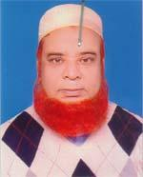 | DR. HAMIDUR RAHMAN (RANA)  F/Name: Late Dr. Alef Uddin Ahmed  M/Name: Late Nurun Nahar Begum  BM & DC Reg. No: 9666  NID: 1020607910245  Cell: 01558337556  Address: Main Road, Santahar, Upazilla-Adamdighi, Dist-Bogra  Blood Group: O+
344 | Voter No  LM-0600344 | DR. MD. ZOBAYED SULTAN  F/Name: Md. Riaz Uddin Mondol  M/Name: Nasima Akhter  BM & DC Reg. No: 38683  NID: 1028808705593  Cell: 01711606254  Address: Sherpur Bus Stand , Hatkhola Road, Sannalpara, Sherpur , Bogra  Blood Group: A+
345 | Voter No  LM-0600345 | DR. MD. MONIRUZZAMAN  F/Name: Late Abul Jobber  M/Name: Mst. Shamsun Nahar Begum  BM & DC Reg. No: 40729  NID: 1018519753689  Cell: 01711578756  Address: Mordern Clinic, Hospital Road, Sherpur, Bogra.  Blood Group: B+
346 | Voter No  LM-0600346  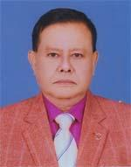 | DR. MD. IQBAL HASAN  F/Name: Late Dr. Md. Saljur Rahman  M/Name: Late Hosney-ara Begum  BM & DC Reg. No: 9627  NID: 19578728209129201  Cell: 01772912959  Address: Associate Prof. Gynae, TMSS. Medical College, Bogra  Blood Group: O+
347 | Voter No  LM-0600347  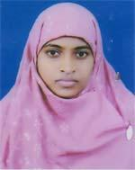 | DR. AFSANA KHANAM  F/Name: Md. Amjad Hossain  M/Name: Selina Begum  BM & DC Reg. No: 60913  NID: 8198510364033  Cell: 01718483746  Address: Baropur Mathaypara, Bogra Sadar, Bogra.  Blood Group: B+
348 | Voter No  LM-0600348  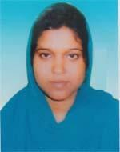 | DR. SHEULY YEASMIN  F/Name: Md. Abdul Wahab Sarkar  M/Name: Sumy Khatun  BM & DC Reg. No: 66383  NID: 8198510364907  Cell: 01719242197  Address: Sharmin Clinic, Bou Bazar, Nataipara, Bogra.  Blood Group: B+
349 | Voter No  LM-0600349 | DR. MONIRUL ISLAM  F/Name: Md. Amzad Hossain  M/Name: Mrs. Mahfuza Khatun  BM & DC Reg. No: 35122  NID: 1028805628120  Cell: 01711954041  Address: Gondogram, Utterpara, Bogra  Blood Group: A+
350 | Voter No  LM-0600350  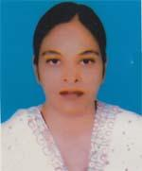 | DR. MST. KHADIZA AMIN  F/Name: Prof. Shafiqul Amin  M/Name: Mrs.msuma Amin  BM & DC Reg. No: 38742  NID:  Cell: 01733444466  Address: Jahurul Nagar, Bogra  Blood Group: B+
351 | Voter No  LM-0600351  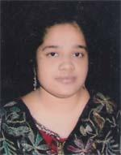 | DR. ZANNATUL KOBRA  F/Name: Saiful Islam  M/Name: Khadijatul Kobra  BM & DC Reg. No: 64266  NID: 2619551919452  Cell: 01751274495  Address: Thanthania West Para, Bogra  Blood Group: A+
352 | Voter No  LM-0600352  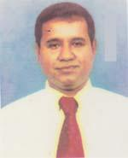 | DR. MD. SALIMULLAH AKAND  F/Name: Md. Gias Uddin Akand  M/Name: Mst. Hasna Banu  BM & DC Reg. No: 32327  NID: 1022001002218  Cell: 01711190193  Address: 4G/Pallab Palace, Sutrapur, Bogra.  Blood Group: A+
353 | Voter No  LM-0600353 | DR. F B M ABDUL LATIF  F/Name: Md. Abdul Hamid  M/Name: Rokeya Hamid  BM & DC Reg. No: 17422  NID: 1022011097218  Cell: 01711267140  Address: Malotinogor (South West to High School), Malotinogor, Bogra.  Blood Group: AB+  E X P I R E D
354 | Voter No  LM-0600354  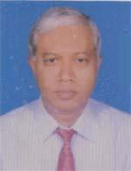 | DR. SK. MD. ABDUL HANNAN MIAH  F/Name:  M/Name:  BM & DC Reg. No: 19716  NID: 2694813898998  Cell: 01715426398  Address: Consultant Bogra Diabetic & Swastaoseba Hospital, Matidali, Bogra  Blood Group: B+  TRANSFERED to BMA Dhaka City  LM-1405543
355 | Voter No  LM-0600355 | DR. SK. MD. ABDUR RAZZAQUE  F/Name: Late Sk. Mozammel Haque  M/Name: Late Jarina Begum  BM & DC Reg. No: 23485  NID: 19673213010000005  Cell: 01712104854  Address: Jhonjhonia, Bogra  Blood Group: AB+
356 | Voter No  LM-0600356 | DR. MD. RAFIUL HASAN  F/Name: Md. Tazul Islam  M/Name: Mst. Dilruba Akhter Banu  BM & DC Reg. No: 74268  NID: 19911022001000141  Cell: 01737040485  Address: Mohona Apartment, FG-A, Snigdha R/A, Nishindara, Sadar, Bogra.  Blood Group: AB+
357 | Voter No  LM-0600357 | DR. MD. ANISUR RAHMAN SIDDIKI  F/Name: Late Abdur Razzak Siddiki  M/Name: Most. Maleka Siddiki  BM & DC Reg. No: 25699  NID: 1028801620477  Cell: 01740950522  Address: Rahman Nagar, Bogra Sadar, Bogra  Blood Group: O+
358 | Voter No  LM-0600358 | DR. MD. ASHRAFUL ISLAM  F/Name: Md. Kanchan Ali  M/Name: Mamataj Begum  BM & DC Reg. No: 62032  NID: 2699038638576  Cell: 01751704004  Address: Bakshi Bazar, Maltinagar, Bogra.  Blood Group: B+
359 | Voter No  LM-0600359 | DR. MD. ABDUL WADUD  F/Name: Late Ataul Islam  M/Name: Ayesha Siddika  BM & DC Reg. No: 27114  NID: 2699501931070  Cell: 01711841781  Address: UHC, Dupchanchia, Bogra.  Blood Group: B+
360 | Voter No  LM-0600360 | DR. MST. ROKSANA SULTANA  F/Name: Late Md. Abdul Bari  M/Name: Nafiza Khatun  BM & DC Reg. No: 37076  NID: 2699501931069  Cell: 01712226373  Address: Thanthania 1st Lane, Thanthania, Bogra  Blood Group: B+
361 | Voter No  LM-0600361  No Image | ***NIL***  F/Name:  M/Name:  BM & DC Reg. No:  NID:  Cell:  Address:  Blood Group:
362 | Voter No  LM-0600362 | DR. MST. AYESHA SIDDIKA  F/Name: Md. Hares Uddin Ahmed  M/Name: Mst. Bilkis Begum  BM & DC Reg. No: 45313  NID: 2692848057866  Cell: 01717203177  Address: C/o-Hares Uddin Ahmed (Teacher), Dupchanchia (Near Pouroshova), Bogra  Blood Group: O+
363 | Voter No  LM-0600363 | DR. ZAKIA ZINAT  F/Name: Md. Zahurul Islam  M/Name: Hasna Banu  BM & DC Reg. No: 49917  NID: 1022010085442  Cell: 01724240980  Address: Rahman Nagar, Zilladarpara, Bogra  Blood Group: O+
364 | Voter No  LM-0600364  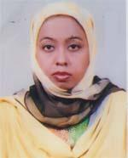 | DR. REZWANA SHAHIN  F/Name: Md. Ramjan Ali  M/Name: Shahin Ara Begum  BM & DC Reg. No: 42648  NID: 1022001008095  Cell: 01816488193  Address: Road No.-02, House No.-06, Uposhahar, Bogra  Blood Group: B+
365 | Voter No  LM-0600365  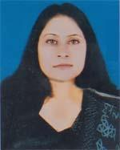 | DR. RUBAIYA JAHAN  F/Name: Late Md. Mujibur Rahman  M/Name: Sadrul Ara Begum  BM & DC Reg. No: 43717  NID: 2691650139203  Cell: 01727301196  Address: House D-10/3, Officers Quarter, Majhira Cantonment, Bogra  Blood Group: A+
366 | Voter No  LM-0600366  No Image | DR. MAHBUBA AKHTER TANIA  F/Name: Munjur Alam  M/Name: Ambia Khatun  BM & DC Reg. No: 61038  NID: 1022011094018  Cell: 01717134688  Address: Bokhshi Bazar, Malotinagor, Bogra.  Blood Group: B+
367 | Voter No  LM-0600367  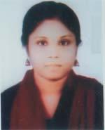 | DR. RAFIAT JOBIRA  F/Name: Md. Rafiqul Islam  M/Name: Mrs. Rehena Islam  BM & DC Reg. No: 62393  NID: 1022020208103  Cell: 01737199549  Address: North Chelopara, Bogra  Blood Group: AB+
368 | Voter No  LM-0600368  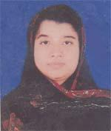 | DR. NAZMUN NAHER POLY  F/Name: Moksed Ahmed  M/Name: Mst. Piara Begum  BM & DC Reg. No: 41337  NID: 2694814904018  Cell: 01716246731  Address: Hazi Para (Bottola Mor) , Thanthania, Bogra.  Blood Group: O+
369 | Voter No  LM-0600369  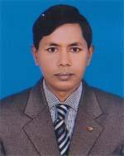 | DR. MD. AZMAL HOSSAIN SHAIKH  F/Name: Late Abul Hashem Shaikh  M/Name: Late Asia Khatun  BM & DC Reg. No: 28741  NID: 1018543600274  Cell: 01734042111  Address: Vill-Duralia, Post-Mazira, P.s-Shajahanpur, Bogra.  Blood Group: B+
370 | Voter No  LM-0600370  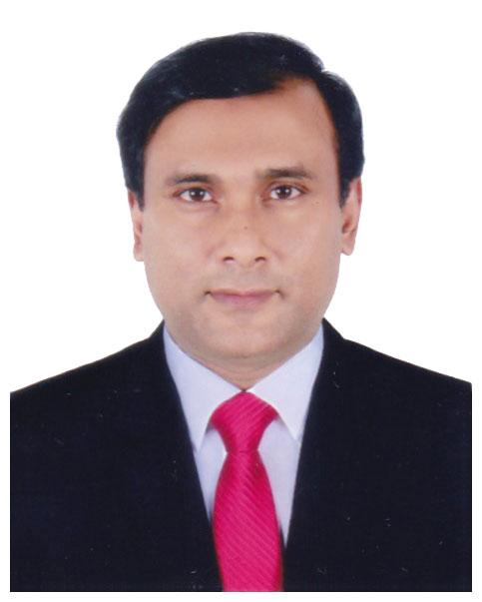 | DR. MD. HASANUZZAMAN  F/Name: Md. Mozibur Rahman  M/Name: Mrs. Hosne Ara  BM & DC Reg. No: 39860  NID: 1018519231855  Cell: 01712177253  Address: Plot: 305, Road: 4/1, Block: A, Sagufta NM Housing, Pallabi, Mirpur-12, Dhaka-1216  Blood Group: O+
371 | Voter No  LM-0600371  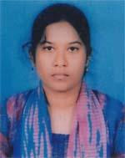 | DR. NOORJAHAN AKTER  F/Name: Md. Afzalul Islam  M/Name: Tazunnachha  BM & DC Reg. No: 62666  NID: 1018517511267  Cell: 01703511522  Address: Thantania (Sufi Mosjid Lane), Sadar, Bogra.  Blood Group: B+
372 | Voter No  LM-0600372  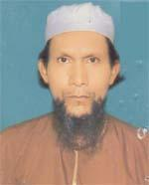 | DR. MD. RAMIJUL HASAN  F/Name: Late Shamsul Huda  M/Name: Mst. Laily Begum  BM & DC Reg. No: 15163  NID:  Cell: n/a  Address: Johurul Nagar, Bogra  Blood Group: n_a
373 | Voter No  LM-0600373 | DR. MD. ZIAUL AHSAN  F/Name: Late Muzibur Rahman  M/Name: Majeda Khatun  BM & DC Reg. No: 15959  NID: 1022010086284  Cell: 01911560808  Address: 250 Beded Mohammad Ali Hospital, Bogra  Blood Group: B+
374 | Voter No  LM-0600374 | DR. SHASHWATI SAHA  F/Name: Sontosh Kumar Saha  M/Name: Shipra Saha  BM & DC Reg. No: 57759  NID: 4124702015720  Cell: 01711965202  Address: Namazgare, Bogra  Blood Group: O+
375 | Voter No  LM-0600375 | DR. MD. MOSHIUR RAHMAN  F/Name: Late Abdul Hamid  M/Name: Late Mohsina  BM & DC Reg. No: 21341  NID: 1022007063422  Cell: 01714546567  Address: North West Building, Khanper, Sahpara, Thanthnia, Bogra  Blood Group: A+
376 | Voter No  LM-0600376  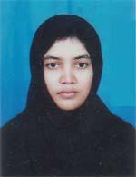 | DR. MST. SABIHA BANU  F/Name: Ansarul Haq  M/Name: Zahida Haq  BM & DC Reg. No: 39161  NID:  Cell: 01706362485  Address: Flat, 7-A, Ghazi Mary Mansion, Sutrapur, Bogra  Blood Group: B+
377 | Voter No  LM-0600377 | DR. MD. IQBAL HOSSAIN  F/Name: Md. Isahaq Ali  M/Name: Sufia Begum  BM & DC Reg. No: 62025  NID: 1028808705316  Cell: 01717064746  Address: Shannal Para, Sherpur, Bogra  Blood Group: O+
378 | Voter No  LM-0600378 | DR. A. K. M. MOSTAFIZUR RAHMAN  F/Name: Late Serajul Islam  M/Name: Late Majeda Begum  BM & DC Reg. No: 19591  NID: 1028513235674  Cell: 01720496039  Address: Lecturer of Microbiology, Shahead Ziaur Rahman Medical College, Bogra  Blood Group: AB+
379 | Voter No  LM-0600379  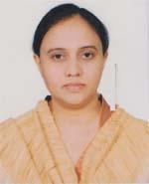 | DR. MARZINA AREFIN  F/Name: Md. Mizanur Rahman  M/Name: Most. Shamsun Nahar  BM & DC Reg. No: 39593  NID: 1022008067176  Cell: 01717427262  Address: Nirjhor, Water Tank Lane, Sheuzgari, Bogra.  Blood Group: B+
380 | Voter No  LM-0600380  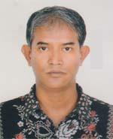 | DR. MD. IBRAHIM KHALILULLAH  F/Name: Late Dr. Md. Abdul Jalil Sheikh  M/Name: Mst. Rawshan Ara  BM & DC Reg. No: 30413  NID: 19758198508263231  Cell: 01714108535  Address: SZMCH, Bogra.  Blood Group: A+
381 | Voter No  LM-0600381  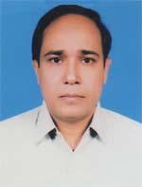 | DR. MD. ZAFAR IQBAL  F/Name: Md. Jalal Uddin  M/Name: Mrs. Shaheda Begum  BM & DC Reg. No: 16397  NID: 1022009079319  Cell: 01944200100  Address: Amicus Vallerin, Jaleshwari Tolla, Bogra  Blood Group: B+
382 | Voter No  LM-0600382 | DR. SUDARSHAN KUMAR TALUKDAR  F/Name: Subash Chandra Talukdar  M/Name: Chhabi Rani Talukdar  BM & DC Reg. No: 39794  NID: 1022003027747  Cell: 01711441090  Address: Fatik Kundu Lane, Katnarpara, Bogra, Assistant Registrar, SZMCH, Bogra  Blood Group: A+
383 | Voter No  LM-0600383 | DR. RAFSANA JAHAN  F/Name: Md. Rafiqul Islam  M/Name: Mrs. Selina Jahan  BM & DC Reg. No: 65819  NID: 1018877077705  Cell: 01711001634  Address: Mordern Clinic & Diagonistic, Hospital Road, Sherpur, Bogra  Blood Group: A+
384 | Voter No  LM-0600384  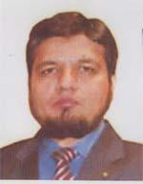 | DR. SHAHRIAR FARUQUE  F/Name: Dr. B. M Faruque  M/Name: Mst. Sabina Yasmin  BM & DC Reg. No: 43892  NID: 19822650898236652  Cell: 01712045011  Address: Gohail Road, Khander, Bogra  Blood Group: AB+
385 | Voter No  LM-0600385  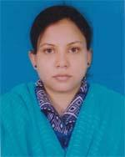 | DR. SAMIA CHHARRA  F/Name: K. M. Abu Raihan  M/Name: Nilufa Banu  BM & DC Reg. No: 45123  NID: 19812650898136510  Cell: 01911703549  Address: Gohail Road, Khandar, Bogra  Blood Group: O+
386 | Voter No  LM-0600386 | DR. MD. MAMUNUR RASHID  F/Name: Md. Jamal Uddin Sarker  M/Name: Mst. Ayesha Siddique  BM & DC Reg. No: 34077  NID: 19772716925565447  Cell: 01716549730  Address: Aziz Kutin, Bono Mahi Elev. Lane Waritola, Bogra  Blood Group: O+
387 | Voter No  LM-0600387  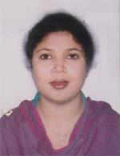 | DR. MST. TAJMARY SULTANA  F/Name: Md. Samsul Alam  M/Name: Mst. Anowara Alam  BM & DC Reg. No: 35592  NID: 19771022020201241  Cell: 01714463102  Address: Aziz Kutir, Bonomali Dev. Lane, Jaleshwari Tola, Bogra  Blood Group: B+
388 | Voter No  LM-0600388  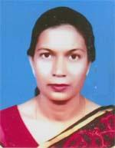 | DR. SHAMEEM AKHTER  F/Name: Late Yasin Ali  M/Name: Meherunnesa  BM & DC Reg. No: 21475  NID: 8198504113839  Cell: 01799652000  Address: Naruli, Bogra  Blood Group: O+
389 | Voter No  LM-0600389 | DR. MD. ATIQUZZAMAN  F/Name: Md. Asaduzzaman  M/Name: Mrs. Fazilatun Nessa  BM & DC Reg. No: 22984  NID: 19681022008069400  Cell: 01717680928  Address: Gohail Road, Sutrapur, Bogra  Blood Group: O+
390 | Voter No  LM-0600390  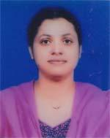 | DR. MUNIRA SHAHNAJ  F/Name: Md. Nurul Islam  M/Name: Mrs. Jahanara Islam  BM & DC Reg. No: 33226  NID: 1022008069401  Cell: 01717353315  Address: Gohail Road, Sutrapur, Bogra  Blood Group: AB+
391 | Voter No  LM-0600391 | DR. MD. NAZIBULLAH  F/Name: Md. Abubakar Siddik  M/Name: Mst. Selina Akhter  BM & DC Reg. No: 50057  NID: 19842694811000078  Cell: 01717338194  Address: House No.-, Road No.-01, Uposhohor, Bogra  Blood Group: A+
392 | Voter No  LM-0600392  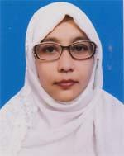 | DR. MST. MOSTANA NAZMA BEGUM  F/Name: M. A. Majid Mollik  M/Name: Mst. Sazeda Begum  BM & DC Reg. No: 57971  NID: 6125215215173  Cell: 01751128940  Address: House No. , Road No.-01, Uposhohor, Bogra  Blood Group: O+
393 | Voter No  LM-0600393 | DR. SAIFUL ISLAM  F/Name: Late Hasen Ali  M/Name: Late Suratan Nesa  BM & DC Reg. No: 18207  NID: 1022003025537  Cell: 01711244104  Address: Hasib Lane, Katnar Para, Bogra  Blood Group: A+
394 | Voter No  LM-0600394  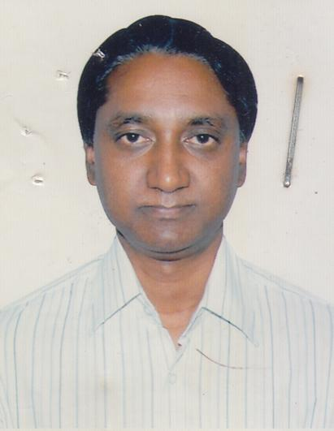 | DR. MD. FARIDUL ISLAM CHOWDHURY  F/Name: Late Abul Kashem Chowdhury  M/Name: Late Mazama Khatun  BM & DC Reg. No: 19929  NID: 1022014237586  Cell: 01711481539  Address: Tesla Neuro Science Hospital , Karosgari, Bogra  Blood Group: B+
395 | Voter No  LM-0600395 | DR. TUNERGINA AKHTER  F/Name: Sheikh Md. Riaz Tullah  M/Name: Sabera Begum  BM & DC Reg. No: 31707  NID: 1018877102417  Cell: 01711904752  Address: Hamsayapur (Kathaltola), Sherpur, Bogra  Blood Group: B+
396 | Voter No  LM-0600396 | DR. SHOURAV KANTI KAR  F/Name: Bidhan Chandra Kar  M/Name: Sangita Rani Kar  BM & DC Reg. No: 59827  NID: 6125217227620  Cell: 01717929358  Address: Sheujgari, Bogra  Blood Group: B+
397 | Voter No  LM-0600397 | DR. SAIKAT MD. REJWANUL HAQUE  F/Name: Md. Jahangir Alam  M/Name: Most. Lutfun Naher Khanum  BM & DC Reg. No: 53308  NID: 8198510364529  Cell: 01740915916  Address: Malotinagar, Paiker Para, Bogra  Blood Group: O+
398 | Voter No  LM-0600398 | DR. BHUBAN MOHAN DEB NATH  F/Name: Monmotha Nath  M/Name: Debi Aruna Nath  BM & DC Reg. No: 62660  NID: 1022007061941  Cell: 01719126251  Address: Jaleswaritala, Bogra  Blood Group: A+
399 | Voter No  LM-0600399 | DR. MD. SAIFUL ISLAM  F/Name: K M A Sayed Mahmud  M/Name: Sabina Yasmin  BM & DC Reg. No: 59082  NID: 6412863261993  Cell: 01724215055  Address: Dhorompur, Bogra Sadar, Bogra  Blood Group: B+
400 | Voter No  LM-0600400  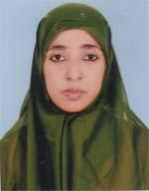 | DR. MST. RUKHSHANA PARVIN  F/Name: S. M. Rafiqul Islam  M/Name: Mst. Firoza Akter  BM & DC Reg. No: 33587  NID: 1022001011253  Cell: 01714495905  Address: Nishindara Kha Para, Bogra  Blood Group: AB+
401 | Voter No  LM-0600401  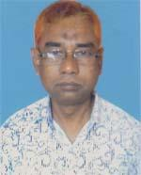 | DR. MD. MUSHFIQUR RAHMAN  F/Name: A. B. M. Mostafizur Rahman  M/Name: Hajera Banu  BM & DC Reg. No: 18316  NID: 19631022009081024  Cell: 01712942263  Address: Gohail Road, Khander, Bogra  Blood Group: AB+
402 | Voter No  LM-0600402 | DR. MD. MAJNU MIA  F/Name: Md. Golam Goffar Pk.  M/Name: Mst. Mannujan Begum  BM & DC Reg. No: 42094  NID: 1022012237928  Cell: 01716941836  Address: Castle Orchid Vally, Bonomali deb Lane, Jawleswari tola, Bogra  Blood Group: O-
403 | Voter No  LM-0600403 | DR. AEYSHA BEGUM  F/Name: Md. Abul Kashem  M/Name: Farida Akter  BM & DC Reg. No: 33011  NID:  Cell: 01723904273  Address: Gohail Road, Sutrapur, Bogra-5800  Blood Group: B+
404 | Voter No  LM-0600404  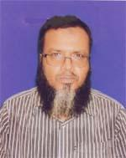 | DR. MD. LIAKOT ALI  F/Name: Md. Riaz Uddin  M/Name: Late Rahimon Khatun  BM & DC Reg. No: 29380  NID: 1022014237588  Cell: 01716718518  Address: Baitur Raian, Green Land Housing, Sabujbag, Bogra  Blood Group: O+
405 | Voter No  LM-0600405  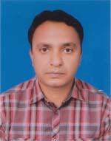 | DR. DHIMAN SAHA  F/Name: Rathindra Nath Saha  M/Name: Manju Saha  BM & DC Reg. No: 47826  NID: 19841028805628482  Cell: 01711488731  Address: Karmokar Para, Sherpur, Bogra  Blood Group: B+
406 | Voter No  LM-0600406 | DR. APON SAHA  F/Name: Uday Sankar Saha  M/Name: Mukti Saha  BM & DC Reg. No: 77863  NID: 19938827808000063  Cell: 01728004973  Address: Karmokar Para, Sherpur, Bogra  Blood Group: AB+
407 | Voter No  LM-0600407 | DR. MD. SAMIUL HAQUE  F/Name: Md. Mofazzal Hossain  M/Name: Mst. Samsunnaher Begum  BM & DC Reg. No: 50322  NID: 19831028806700869  Cell: 01711385335  Address: Village-Ulipur, Post+P.s-Sherpur, Dist-Bogra  Blood Group: B+
408 | Voter No  LM-0600408 | DR. NIL RATAN DEB  F/Name: Nikunja Bihari Deb  M/Name: Minoti Rani Deb  BM & DC Reg. No: 50706  NID: 8524904042971  Cell: 01722304009  Address: Vill+Post-Kagail, P.s-Gabtoli, Dist-Bogra  Blood Group: O+
409 | Voter No  LM-0600409  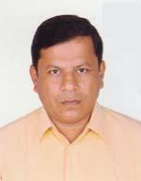 | DR. PANKAJ KUMAR MOHANTA  F/Name: Prafullah Kumar Mohanta  M/Name: Chaya Rani Mohanta  BM & DC Reg. No: 20154  NID: 6926307373266  Cell: 01733154081  Address: Mohammad Ali Hospital, Bogra  Blood Group: B+
410 | Voter No  LM-0600410  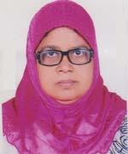 | DR. PARVEEN BANU  F/Name: Late Sajjad Hossain  M/Name: Mrs. Shirifa Khatun  BM & DC Reg. No: 9737  NID: 1022010086036  Cell: 01712040212  Address: 5/C, Tropical Elias Prangon, Jailmore, Jaleswaritola, Bogra  Blood Group: A+
411 | Voter No  LM-0600411  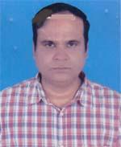 | DR. S. M. RUHUL AMIN  F/Name: Late A. Z. Nur Mohammad  M/Name: Mrs. Anowara Begum  BM & DC Reg. No: 29610  NID: 1028808705155  Cell: 01711167299  Address: Upazilla Health Complex, Kahalu, Bogra  Blood Group: A+
412 | Voter No  LM-0600412  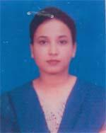 | DR. UMME SALMA SHARMIN  F/Name: Md. Mostafizur Rahman  M/Name: Mst. Mahamuda Khatun  BM & DC Reg. No: 42474  NID: 1028808705619  Cell: 01738646507  Address: Upazilla Health Complex, Sazahanpur, Bogra  Blood Group: O+
413 | Voter No  LM-0600413 | DR. MAGFUR MD. TALEBUL FERDOUS  F/Name: Late Dr. Abdul Gaffar Sardar  M/Name: Late Firoza Begum  BM & DC Reg. No: 44118  NID: 2697557398608  Cell: 01716616068  Address: S.P. Banglow Lane, Malatinagar, Bogra  Blood Group: B+
414 | Voter No  LM-0600414  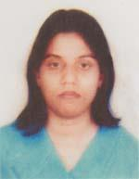 | DR. SALEHA KHATUN  F/Name: G. M. Habibullah  M/Name: M. S. Humyra  BM & DC Reg. No: 44732  NID: 8192227427700  Cell: 01720102275  Address: S.P Banglo Lane, Malati Nagar, Bogra  Blood Group: A+
415 | Voter No  LM-0600415 | DR. MD. MAMUN UR RASHID  F/Name: Md. Akram Hossain  M/Name: Mrs. Munnujan Begum  BM & DC Reg. No: 58812  NID: 1022003028658  Cell: 01717506873  Address: House No.-28, Kishori Rai Lane, Sribboti, Bogra  Blood Group: A+
416 | Voter No  LM-0600416  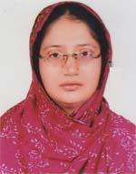 | DR. MST. ARIFA SHIRIN  F/Name: Md. Arzad Hossain  M/Name: Shamim Ara  BM & DC Reg. No: 42367  NID: 2690243829192  Cell: 01816343367  Address: Khan Lodge, Gohail Road, Sutrapur, Bogra  Blood Group: O+
417 | Voter No  LM-0600417 | DR. AFIFA RAHMAN  F/Name: Md. Fazlur Rahman  M/Name: Meher Sultana  BM & DC Reg. No: 41672  NID: 2694811019442  Cell: 01711208201  Address: Thonthonia, Hazipara, Bogra  Blood Group: O+
418 | Voter No  LM-0600418  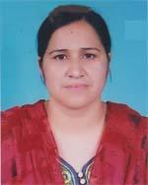 | DR. NOFISA KHATUN  F/Name: Md. Lutfar Rahman  M/Name: Mst. Mazeda Begum  BM & DC Reg. No: 42741  NID: 1018551867689  Cell: 01716093667  Address: City Clinic, Rahman Nagar, Bogra  Blood Group: A+
419 | Voter No  LM-0600419 | DR. MD. SHOEBUL ALAM SHUVO  F/Name: Md. Zahidul Alam  M/Name: Begum Saleha Alam  BM & DC Reg. No: 60891  NID: 2716469409566  Cell: 01795859683  Address: Shib-Bati, Bridge Road, Bogra  Blood Group: AB+
420 | Voter No  LM-0600420  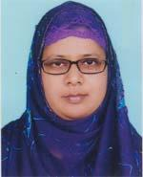 | DR. SHARMIN AFROZY  F/Name: Md. Mosharaf Hossain  M/Name: Altafunnesa  BM & DC Reg. No: 30748  NID: 1022009078422  Cell: 01816192178  Address: Bani Mohol , Sutrapur, Bogra Town, Bogra  Blood Group: B+
421 | Voter No  LM-0600421 | DR. MD. SHAJEDUL ISLAM  F/Name: Md. Ismail Hossain Sarker  M/Name: Mst. Shirina Akter  BM & DC Reg. No: 66757  NID: 2697556419210  Cell: 01777646789  Address: Ranisankail Upazilla Health Complex, Thakurgaon  Blood Group: A+
422 | Voter No  LM-0600422 | DR. JESMIN SULTANA  F/Name: Md. Abdus Samad  M/Name: Malika Afroz  BM & DC Reg. No: 45661  NID: 1022001002659  Cell: 01731255911  Address: Amin Mansion, C/A-1, Main Road, Uposahor, Bogra  Blood Group: O+
423 | Voter No  LM-0600423  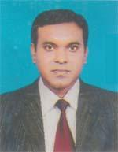 | DR. MD. AMIRUL ISLAM  F/Name: Late Amzad Hossain  M/Name: Mst. Nurzahan Hosneara  BM & DC Reg. No: 35865  NID: 1028802622547  Cell: 01711013981  Address: 7/H, Monzur Tower, Sutrapur, Bogra  Blood Group: O+
424 | Voter No  LM-0600424 | DR. MD. ENAMUL HOQUE  F/Name: Md. Abdul Latif  M/Name: Mrs. Basiron Khatun  BM & DC Reg. No: 51036  NID: 2694266781295  Cell: 01725595354  Address: Vill-Bati, Post-Bonarpara, Thana-Shaghatta, Dist-Gaibandha  Blood Group: A+
425 | Voter No  LM-0600425  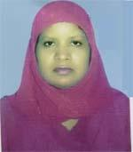 | DR. SULTANA RAZIA  F/Name: Late Azizur Rahman  M/Name: Late Altafunessa  BM & DC Reg. No: 20032  NID: 1015485787821  Cell: 01711284202  Address: Assistant Prof. Shahid Ziaur Rahman Medical College, Bogra  Blood Group: AB+
426 | Voter No  LM-0600426  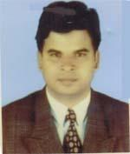 | DR. MD. ABDUL MANNAN MIAH  F/Name: Late Abdul Baset Miah  M/Name: Rokeya Begum  BM & DC Reg. No: 18731  NID: 1015485787844  Cell: 01711391684  Address: Medical Officer (CMH-FP), Bogra Sadar, Bogra  Blood Group: O+
427 | Voter No  LM-0600427  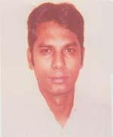 | DR. MD. AHSANUZZAMAN  F/Name: Md. Shahadat Zaman  M/Name: Mrs. Afroza Zaman  BM & DC Reg. No: 45461  NID: 1022011094014  Cell: 01723813826  Address: Rajshahi Medical College Hospital, Ortho Surgery  Blood Group: B+
428 | Voter No  LM-0600428  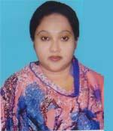 | DR. OYHEDA OMER SHAPLA  F/Name: Md. Omer Ali  M/Name: Halima Begum  BM & DC Reg. No: 51836  NID: 1022012113927  Cell: 01722147157  Address: Chalkfarid Colony Sherpur Road, Bogra  Blood Group: O+
429 | Voter No  LM-0600429 | DR. HASAN SHAHID MD. REZAUNNABI MONDAL  F/Name: Md. Abedul Khaleque Mondal  M/Name: Mrs. Anowara Begum  BM & DC Reg. No: 19119  NID: 4915217187714  Cell: 01713493391  Address: Jaleswaritola, Bogra  Blood Group: A+
430 | Voter No  LM-0600430 | DR. ZINAT SHAHREEN  F/Name: Md. Delwar Hossain  M/Name: Mrs. Khaleda Hossain  BM & DC Reg. No: 44793  NID: 2650898264302  Cell: 01715006760  Address: Saikat 10/5, SSD Area Bogra Cantt. Majhira, Bogra  Blood Group: AB+
431 | Voter No  LM-0600431 | DR. MD. REZAUL HOSSAIN  F/Name: Late Dr. Tozammol Hossain  M/Name: Late Firoza Begom  BM & DC Reg. No: 53286  NID: 1022001001927  Cell: 01711937119  Address: Sharif Mahal, Namazghor, Bogra  Blood Group: B+
432 | Voter No  LM-0600432  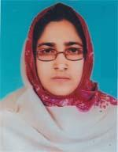 | DR. MST. NASRINA BEGUM  F/Name: Md. Kashem Ali Mondal  M/Name: Most. Sufia Khatun  BM & DC Reg. No: 27073  NID: 6426002112787  Cell: 01712218199  Address: Flat No.-3A, Newaz Living Centre, Jalashwritola, Bogra  Blood Group: O+
433 | Voter No  LM-0600433 | DR. SHARMIN AKTER  F/Name: Md. Shahjahan Ali  M/Name: Mrs. Nurun Nahar Begum  BM & DC Reg. No: 38073  NID: 19792696653267392  Cell: 01747841450  Address: Dewan Tower, Flat-C1, Gohail Road, Sutrapur, Bogra  Blood Group: A+
434 | Voter No  LM-0600434 | DR. MD. MAHMUD KABIR  F/Name: Late Rakim Uddin Pramanik  M/Name: Late Mowluda Khatun  BM & DC Reg. No: 17595  NID: 1022011096320  Cell: 01718312080  Address: Vill-Maltinagar, Post-Bogra, P.s-Sadar, Dist-Bogra  Blood Group: A+
435 | Voter No  LM-0600435  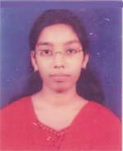 | DR. ISHITA MAJUMDER  F/Name: Dr. Bidhan Chandra Majumder  M/Name: Dr. Shefali Rani Majumder  BM & DC Reg. No: 71122  NID: 19901022011000106  Cell: 01715181672  Address: Maltinagar (East Side of Girja) Post & Dist-Bogra  Blood Group: B+
436 | Voter No  LM-0600436 | DR. MOUSUMI MAJUMDER  F/Name: Dr. Bidhan Chandra Majumder  M/Name: Dr. Shefali Rani Majumder  BM & DC Reg. No: 78588  NID: 19921022011000036  Cell: 01738372339  Address: Maloti Nagar, Chanmarighat Lane, Bogra  Blood Group: B+
437 | Voter No  LM-0600437 | DR. MD. MASRURUL HAQUE  F/Name: Nurun Nabi  M/Name: Mahmuda Khatun  BM & DC Reg. No: 62065  NID: 19891022010088072  Cell: 01727497535  Address: Holding No.-787, Rahman Nagar, Ziladar Para, Bogra  Blood Group: A+
438 | Voter No  LM-0600438 | DR. MD. SHAWKAT JAMIL  F/Name: Md. Abul Kashem  M/Name: Shefa-unnesa  BM & DC Reg. No: 30959  NID: 3811347329609  Cell: 01711952511  Address: EMO, Shahid Ziaur Rahman Medical College Hospital, Bogura.  Blood Group: A+
439 | Voter No  LM-0600439  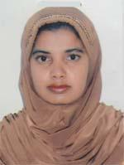 | DR. HABIBA SULTANA  F/Name: Md. Idris Ali  M/Name: Mazeda  BM & DC Reg. No: 37528  NID: 3811347329610  Cell: 01712688143  Address: Prince House, Modina Mosque, Jahurul Nagar, Bogra  Blood Group: B+
440 | Voter No  LM-0600440 | DR. SUSHANTO KUMAR PAUL  F/Name: Shadhanando Paul  M/Name: Minoti Das  BM & DC Reg. No: 57837  NID: 8514939387568  Cell: 01761777944  Address: Grameen G.C Eye Hospital, Betgari, Bogra.  Blood Group: O+
441 | Voter No  LM-0600441 | DR. MD. MAJIBAR RAHMAN  F/Name: Abdul Majid Miah  M/Name: Hasina Begum  BM & DC Reg. No: 17920  NID: 1022008073451  Cell: 01819660018  Address: Sheujgari Talukder Para, Bogra  Blood Group: B+
442 | Voter No  LM-0600442  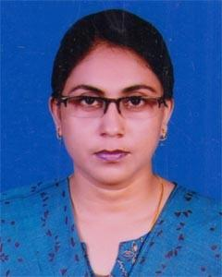 | DR. JOYUTPALA SHUKLA  F/Name: Sonatan Chandra Seal  M/Name: Shefali Rani Shil  BM & DC Reg. No: 34203  NID:  Cell: 01717-66440  Address: Jogonnath Para , Sherpur, Bogura  Blood Group:
443 | Voter No  LM-0600443 | DR. A.N.M. GOLAM HAMEEM  F/Name: Late Dr. A.N.M. Abdul Monyem  M/Name: Habiba Nazni  BM & DC Reg. No: 75084  NID:  Cell: 01788-200387  Address: Khondakaerpara, Sherpur, Sherpur, Bogura.  Blood Group:
444 | Voter No  LM-0600444  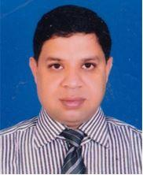 | DR. MINHAZUL HAQUE  F/Name: Md. Siddequar Rahman  M/Name: Mrs. Rokeya Akhter  BM & DC Reg. No: 52342  NID: 1022005045868  Cell: 01741-510260  Address: Perfect Skin Care, Mofiz Paglar More,Sherpur Road, Bogura  Blood Group: B+
445 | Voter No  LM-0600445 | DR. SHAOKAT AKTAR JAHAN  F/Name: Md. Shaokat Ali  M/Name: Selina Begum  BM & DC Reg. No: 79032  NID: 19917026612100006  Cell: 01761-370668  Address: Moyessh Miar Baganbari, Kanochgari, Bogura.  Blood Group: B+
446 | Voter No  LM-0600446 | DR. MD. P.K. SHAHI  F/Name: Md. Zakir Hossain  M/Name: Mrs. Rejeka Begum  BM & DC Reg. No: 50811  NID: 1022009076416  Cell: 01741-510260  Address: Malgram Dokhin Para, Kandar, Bogura Sadar, Bogura.  Blood Group:
447 | Voter No  LM-0600447  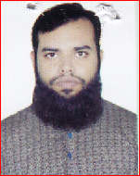 | DR. ABDUS SABUR  F/Name: Md. Martaza Taufiqul Islam  M/Name: Miss. Shahanaz Begum  BM & DC Reg. No: 86554  NID: 19913811331000239  Cell: 01916-861464  Address: Vill- Gudumba, P.O : Kashira Uppazila : Akkelpur, Dist.: Joupurhat.  Blood Group: B+
448 | Voter No  LM-0600448  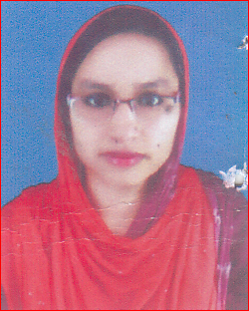 | DR. ROKEYA KHANOM  F/Name: Raihan Khan  M/Name: Beli Khanom  BM & DC Reg. No: 75811  NID: 3816115698425  Cell: 01737-128568  Address: Sultangonjpara, Bogura  Blood Group: O+
449 | Voter No  LM-0600449  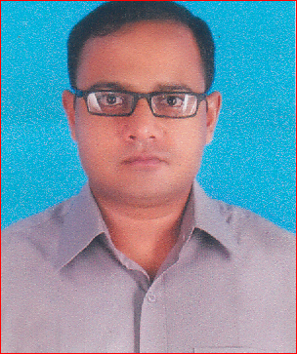 | DR. ADNAN MUHAMMAD ASHKARY  F/Name: Md. Abu Bakar Sarker  M/Name: Anjuman Ara  BM & DC Reg. No: 66086  NID: 2371293362  Cell: 01795-036650  Address: Hoding : 16, Ward -7, Toun Colony, P.O. : Sherpur, Dist. : Bogura.  Blood Group:
450 | Voter No  LM-0600450 | DR. SADIA TABUSSUM  F/Name: A.K.M. Monowar Hossin  M/Name: Mahmuda Hossin  BM & DC Reg. No: 78759  NID:  Cell: 01749-056225  Address: Sauggari Water Tank Road, Bogura.  Blood Group: O+
451 | Voter No  LM-0600451 | DR. MD. SHAHNEWAZ HOSSAIN  F/Name: Md. Rezowan Hossain  M/Name: Sayeda Hosne Ara  BM & DC Reg. No: 38584  NID: 5541859327  Cell: 01819147157  Address: DC Banglow Road, Malotinagar, Bogura.  Blood Group: O-
452 | Voter No  LM-0600452 | DR. DIBAKAR BASAK  F/Name: Late. Dizendra Nath Basak  M/Name: Shamoli Rani Basak  BM & DC Reg. No: 74571  NID: 19891010640974686  Cell: 01774983480  Address: MS Club Road, Roich Fokirer Mor, Malo Tinagar, Bogura.  Blood Group: A+
453 | Voter No  LM-0600453  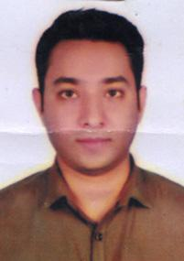 | DR. A.K.M.MEHEDI HASAN  F/Name: Md. Fazlar Rahman  M/Name: Mst. Monowara Sultana  BM & DC Reg. No: 65508  NID: 9144644854  Cell: 01719707610  Address: UHC, Akkelpur,, Joypurhat  Blood Group: O+
454 | Voter No  LM-0600454  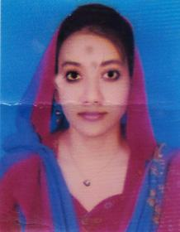 | DR. RAISA TAHSIN  F/Name: Md. Salauddin Siddiqui  M/Name: Tahmina Islam  BM & DC Reg. No: 72959  NID: 19902697556000275  Cell: 01755949207  Address: UHC, Akkelpur, Joypurhat.  Blood Group: B+
455 | Voter No  LM-0600455 | PROFESSOR DR. MD. ZAKIR HOSSAIN  F/Name: Late. Alhaz Wasim Uddin Ahmed  M/Name: Late. Waleda Khatun  BM & DC Reg. No: 15610  NID:  Cell: 01713210336  Address: Waleda Cottage, House No: 1488/A Road No: 04 Jan-E-Saba Housing Complex Jamil Nagor, Bogura.  Blood Group: B+
456 | Voter No  LM-0600456 | DR. MD. LOKMAN HOSSAIN  F/Name: Md. Abdur Rahim  M/Name: Mrs. Hosne Ara  BM & DC Reg. No: 44184  NID: 9108380297  Cell: 01712294416  Address: Hosne ara Monzil, B-Blook Bogura Cantl, Shajahan pur, Bogura.  Blood Group: O+
457 | Voter No  LM-0600457  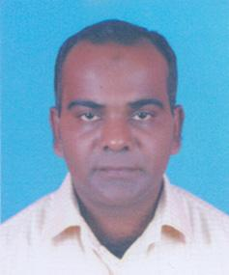 | MD. EMRAN ALI KHANDKER  F/Name: Md. Abdul Jobbar Khandker  M/Name: Asma Khandker  BM & DC Reg. No: 55414  NID: 1943561066  Cell: 01734208554  Address: West Side of Shohid Chandu Stadiur, Bogura Sadov, Bogura.  Blood Group: B+
458 | Voter No  LM-0600458 | DR. A.H.M.SANJEDUL HAQUE SUMON  F/Name: Md. Abdul Mozid  M/Name: Begum Sufia Mozid  BM & DC Reg. No: 46333  NID: 1022012105589  Cell: 01717515280  Address: Latifpur, Post: Bogura, Thana- Bogura Sadar Dist: Bogura.  Blood Group: A+
459 | Voter No  LM-0600459 | DR. PARVIN AKTER  F/Name: Md. Abdur Rahim  M/Name: Sabiron Nesa  BM & DC Reg. No: 55809  NID: 8524904042550  Cell: 01706362464  Address: Latifpur, Post: Bogura, Thana- Bogura Sadar Dist: Bogura.  Blood Group: O+
460 | Voter No  LM-0600460  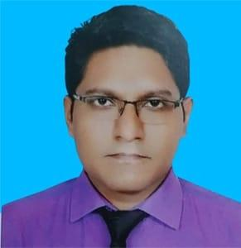 | DR. A.N.M. MAHMUDUN NABI  F/Name: Md. Abdur Rouf  M/Name: Mst. Nurun Nahar  BM & DC Reg. No: 104104  NID: 1503186239  Cell: 01744665571  Address: Choklokman, Uttar Para, Bogura Sadar, Bogura-5800.  Blood Group: AB+
461 | Voter No  LM-0600461  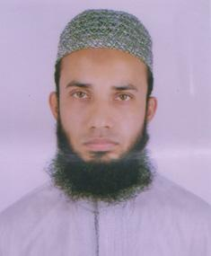 | DR. KHAZA AMIRUL ISLAM  F/Name: Khaza Ashrafuzzaman  M/Name: Khaza Farida Ashraf  BM & DC Reg. No: 58161  NID: 1024875344  Cell: 01761338884  Address: Flat 1-B, Nafiz Nikcton, Sutrapur Eidgah Bogura.  Blood Group: AB+
462 | Voter No  LM-0600462  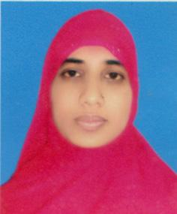 | DR. TANIA AFROSE  F/Name: Md. Jamshed Alam  M/Name: Khurshida Begum  BM & DC Reg. No: 66019  NID: 19863821304000003  Cell: 01717442534  Address: Flat-1-B, Nafiz Niketon, Sutrapur Eidgahmath. Bogura.  Blood Group: O+
463 | Voter No  LM-0600463  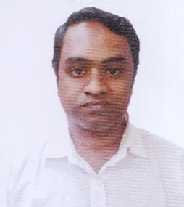 | DR. MD. SHAFIUL AZAM  F/Name: Md. Abdul Jabbar  M/Name: Shahina Jabbar  BM & DC Reg. No: 43014  NID: 19822697557395580  Cell: 01717017117  Address: Naruli, Bogura Pourasava, Bogura Sadar Bogura.  Blood Group: O+

